Trường: Tiểu học Hứa Tạo  Họ và tên:................................  Lớp: 4 … |  | THE SECOND TERM TEST  ENGLISH GRADE 4  Năm học : 2014 - 2015  Time: 40 minutes | Số thứ tự bài thi
Số BD Phòng | Điểm | Nhận xét | CK GT
A. PAPER 1 : LISTENING (5m)

Question 1. Listen and number : (1m) Example : E - 0
A B C D E
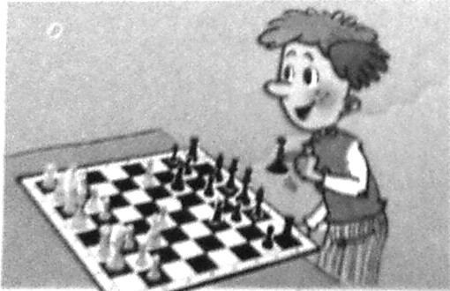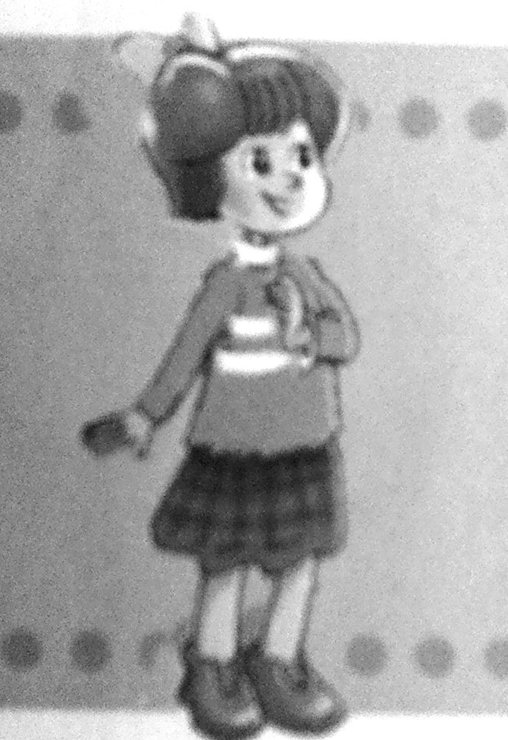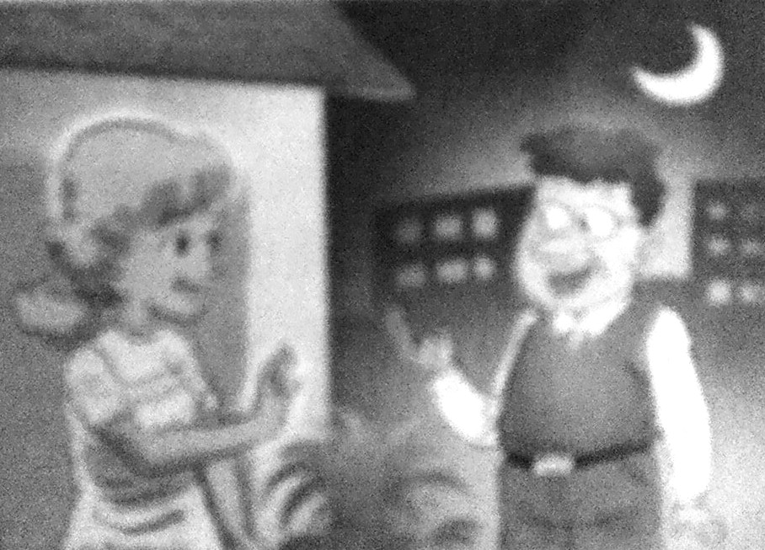
0

Question 2 . Listen and colour : (1m)
1 2 3 4





Question 3. Listen and draw a line : (1m)

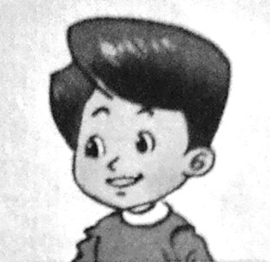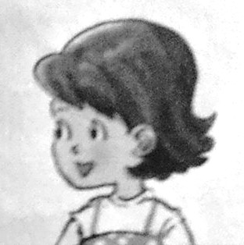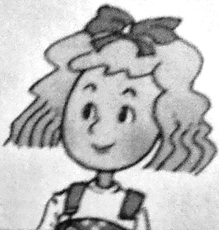
NAM NGA PHONG HOA LINDA

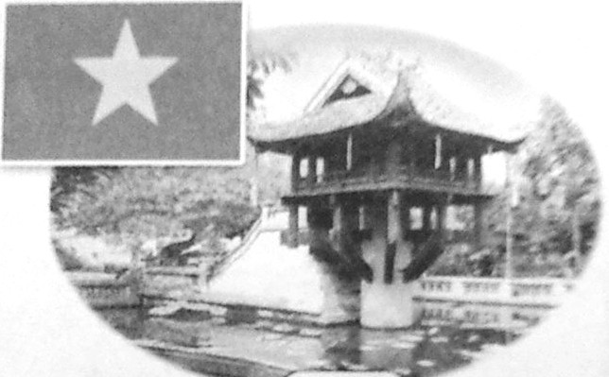
A B C D E
Question 4. Listen and tick the correct picture : (1m)
I like ..........................
Example :
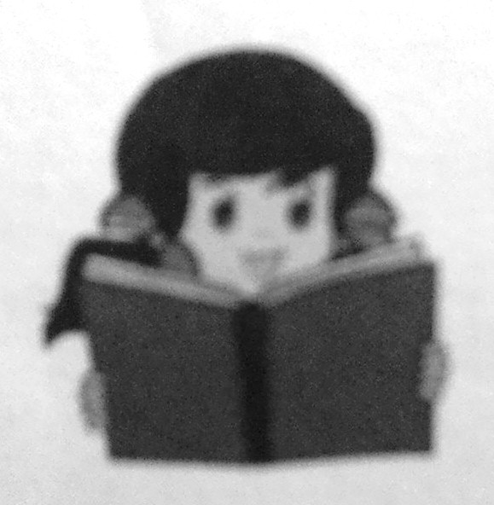
A B ü C
1
What day is it today?
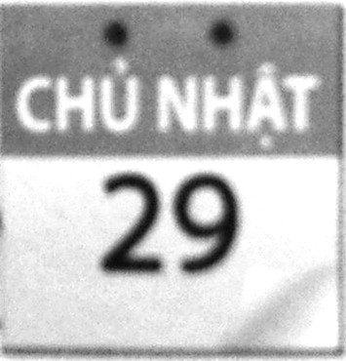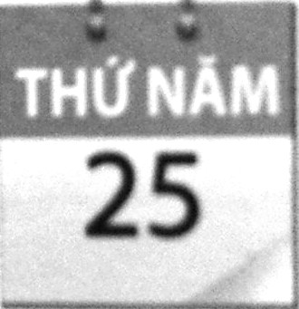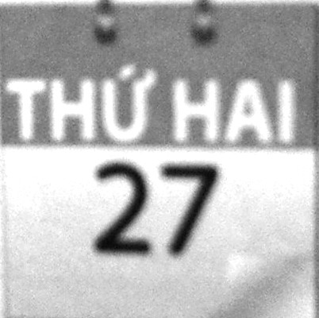
A B C
2
What subject have you go today?
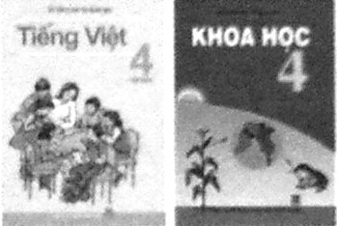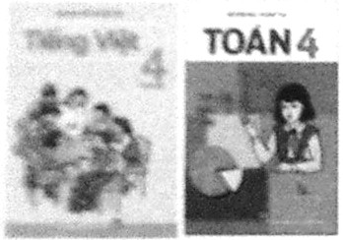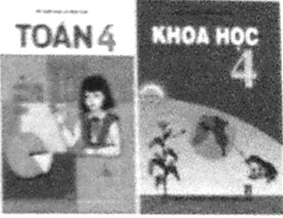
A B C
3
What is this?
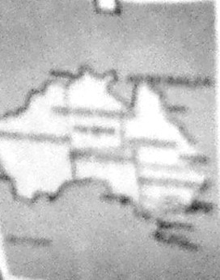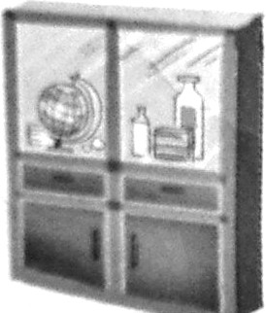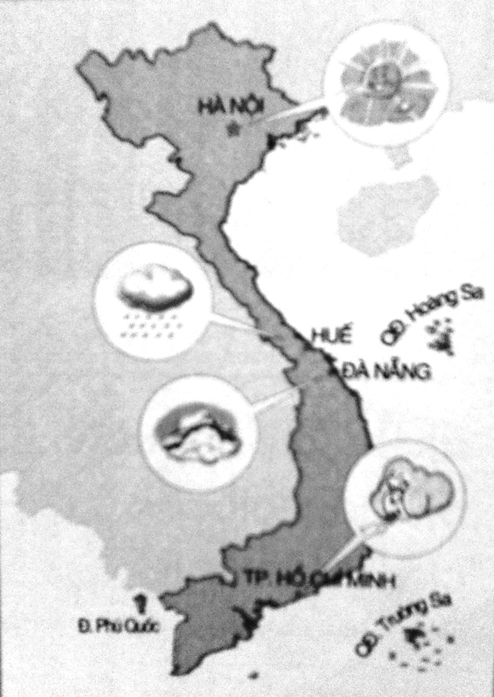
A B C
4
Do you like ………………………..?
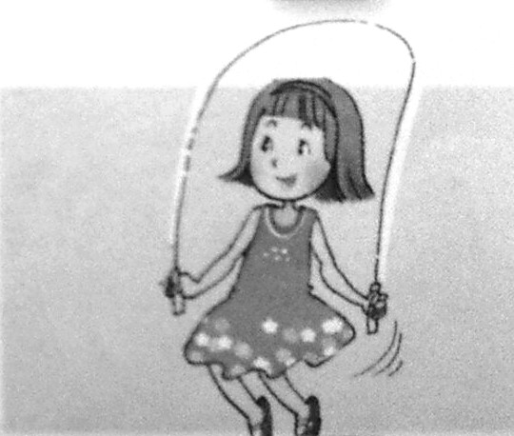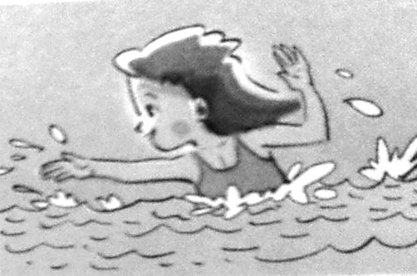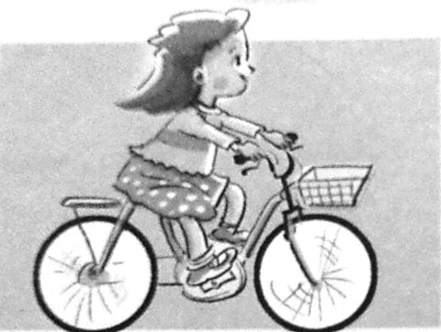
A B C
Question 5 . Listen and complete : (1m)
Example : Hello, I’m Linda . I’m from England
I love music but I can’t play the piano.
1. That Ha Noi ………………………… School.
It’s in Lieu Giai Street.
2. A: When is your birthday, Nam ?
Nam: It’s in …………………………
3. A: What day is it today?
B: It’s …………………………..
4. Who’s over there ?
B: That’s my new ……………………….
Trường: Tiểu học Hứa Tạo  Họ và tên:................................  Lớp: 4 … |  | THE SECOND TERM TEST  ENGLISH GRADE 4  Năm học : 2014 - 2015  Time: 40 minutes | Số thứ tự bài thi
Số BD Phòng | Điểm | Nhận xét | CK GT
PART II. READING AND WRITING (15’)

Question 6. Look and read. Put a tick or cross in the box as examples (1m).


0. Lan can skip.

00. There is one painting on the wall .

1. He likes reading.



2. Bully is taller, bigger and stronger.
Bully Billy


3. Mai can draw a tree.



4. He’s making a plane.

Question 7. Read and write ONE suitable word in each gap (1m)
0. This is Nam’s timetable .
Mon. | Tue. | Wed. | Thu. | Fri.
English | Maths | V.mese | Science | V.mese
Maths | V.mese | English | English | V.mese
Geography | V.mese | Maths | Maths | Maths
Vietnamese | Music | History | V.mese | Science
Art | P.E | Computer | V.mese | English

- Nam ______ got Vietnamese and Maths everyday.

- He’s got English times a week.

- He’ s got Science ______________a week.

4. He’ s got History on .


Question 8. Look at the pictures. Look at the letters. Write the words. (1 pt)
Example:
giignns s i n g i n g


1. obrdacpu _ _ _ _ _ _ _

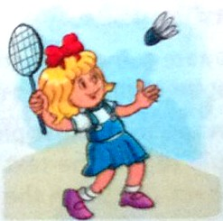
2. indtomban _ _ _ _ _ _ _ _ _


3. nrosgt _ _ _ _ _ _

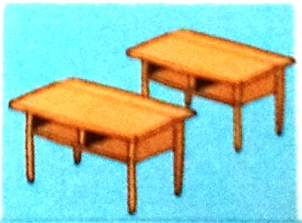
4. skeds _ _ _ _ _

Question 9. Look at the pictures. Complete the paragraph. (1 m)


Mai’s from (0) Vietnam. She’s (1) . She (2)

_____________at Hanoi International School. She’s in class 4A. Her hobby is (3)



____________ . In her school subjects, she likes (4) ______________


best. She can ride a bike and she likes playing (5) ______________after school.

PART III. SPEAKING (1pt) (5 minutes)

1. Listen and repeat. 2. Point, ask and answer.

3. Listen and comment. 4. Interview.

The End
ANSWER KEYS – ENGLISH 4

A. PAPER 1 : LISTENING (5m)
Question 1. Listen and number : (1m) Example : E – 0
1. A 2.D 3. B 4. C
Question 2 . Listen and colour ( 1m)
1. pink 2. green 3. brown 4. yellow
Question 3. Listen and draw a line : (1m)
1. NGA – C 2. LINDA – B 3. HOA – D 4. PHONG - A
Question 4. Listen and tick the correct picture : (1m)
1. C 2. B 3. C 4. A
Question 5 . Listen and complete : (1m)
1. International 2. December 3. Wednesday 4. classmate

PART II. READING AND WRITING (15’)
Question 6. Look and read. Put a tick or cross in the box as examples (1m).
1. X 2. ü 3. ü 4. X
Question 7. Read and write ONE suitable word in each gap (1m)
1. has 2. four 3. twice 4. Wednesday
Question 8. Look at the pictures. Look at the letters. Write the words. (1 pt)
1. cupboard 2. badminton 3. strong 4. desks
Question 9. Look at the pictures. Complete the paragraph. (1 m)
1. Vietnamese 2. study / learn 3. cooking 4. volleyball

