Name: ……… Review for semester 2- grade 3
Class: ………..
I.Vocabulary:
1. Family members: father
………………………………………………………………………………………………………………………………………………………………………………………………….
2.Phòng trong nhà:
living room,
…………………………………………………………………………………………..
- Đồ dùng trong nhà:
………………………………………………………………………………………………………………………………………………………………………………………………………………………………………………………………………………………………………
4.Giới từ: on,…………………………………………………………………………………
5. Số đếm 1-100
………………………………………………………………………………………………………………………………………………………………………………………………….
………………………………………………………………………………………………………………………………………………………………………………………………….
………………………………………………………………………………………………………………………………………………………………………………………………….
………………………………………………………………………………………………………………………………………………………………………………………………….
………………………………………………………………………………………………………………………………………………………………………………………………….
6.Đồ chơi (toys)
……………………………………………………………………………………………………………………………………………………………………………………………………………………………………………………………………………………………
7.Con vật (pets)
……………………………………………………………………………………………………………………………………………………………………………………………………………………………………………………………………………………………
8.Weather:
…………………………………………………………………………………………….
9. Động từ +ing
Ví dụ: reading
………………………………………………………………………………………………………………………………………………………………………………………………….
………………………………………………………………………………………………………………………………………………………………………………………………….
Part I. Listening
Question 1: Listen and number. There is an example
A   | B   | C 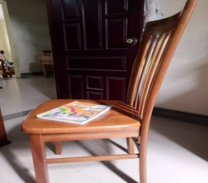 | D   | E  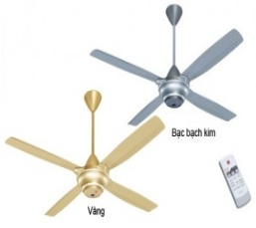
0

Question 2 : Listen and match. There is an example
A.   | B.  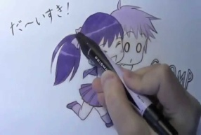 | C. 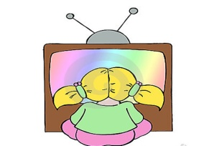 | D.  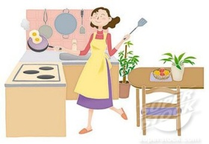 | E.  

0.Hoa
3. Peter Peter
1.Tony
4.Linda
2.Mai

Question 3: Listen and tick . There is an example:

1. What are they doing?
A. 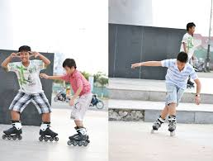 B. 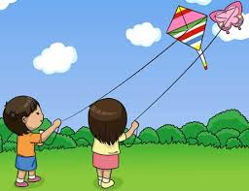 C. 
2.What’s he doing?
A.  B.  C. 
3.Do you have any pets?
A.  B.  C. 
4.What’s the weather like in Ho Chi Minh City?
A.  B.  C. 

Question 4: Listen and tick A, B or C. There is an example
- Who’s that ?
A.She’s my mother. B. She’s my sister. C. She’s my friend.
- How many parrots do you have?
A.I have five. B. I have four. C. I have one.
- What toys do you like?
A.I like ships. B. I like planes. C. I like balls.
3. How old is your brother?
A.He’ six years old. B. He’s fourteen. . C. He’s seven years old.
4. Where are Nam and Quan ?
A.They’re in the park. B. They’re at home. C.They’re at school.

Question 5: Listen and complete. There is an example
- Is there a (0) pond ? Yes, there is.
- There is a (1) …………………..……. It’s very nice!
- I like (2) …………………. days.
- How old is your grandfather? He’s (3)……………………..… years old.
- Where are the cats? They’re (4) …………………. ………………..
Part II: Reading and writing.
Question 6: Match the pictures with the words. There is an example

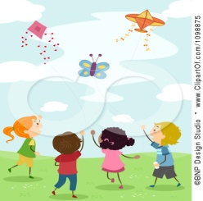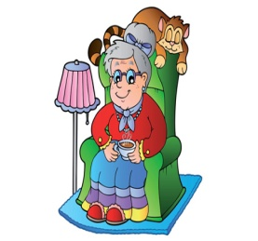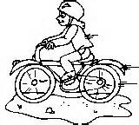
A B C D E

a rabbit | grandfather | a parrot | flying kites | grandmother | rainy | ride a bike

Question 7: Choose a word from the box and write it next to numbers from 1 – 4. There is an example:

Mai’s family

Today is Sunday. It’s (0) sunny. Mai’s family is at home. Mai’s father is in the living room . He is (1) ………………… newspaper. Mai’s(2)………………. is in the garden . He’s playing (3) ………………… with his friends. Mai is listening to music in her bedroom. Her mother is in the (4) ……………........ She is cooking. Mai’s family has a nice day.

 | 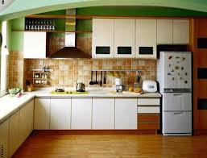 |  |  | 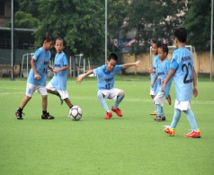 | 
brother | kitchen | sunny | reading | football | swimming
Question 8: write the words.
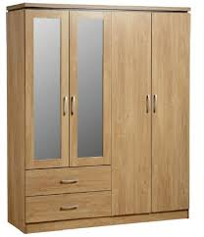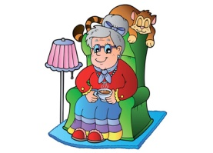

wardrobe ……………… …………………….. ………………….. ………………….

……………… …………………….. ………………….. …………………. ………………
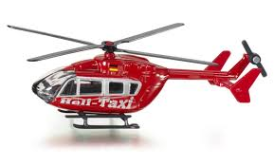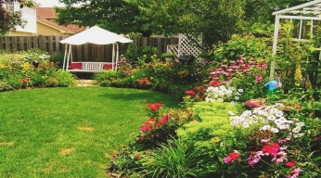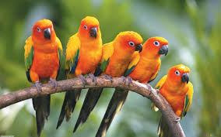

……………… …………………….. ………………….. …………………. ………………….

Question 9: Write correct words with pictorial hints. There is an example:(1pt)
- I have three cats. .
- There is a ………………… in my bedroom.
- There is a ………………… 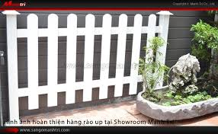 around the house.
- Peter has a ……………. . 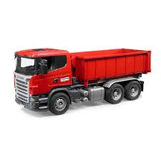 and ……………....……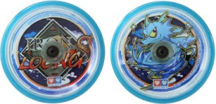.
- The ball’s ………………………………...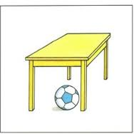
- There is a  ………………….in front of the house.
- My mother is in the ……………..,. She’s cooking.
- The children are  ………………………… in the park now.
- The boys are ……………….. to school everyday.
- His father is ………………… in the living room.
- The weather is …………………. today.

Question 10. Complete

like trucks How ten cats
I have many toys. I have five (1) trucks, three planes, and (2) ………. yo-yos. My friend Hoa has some pets. She has two dogs and three (3) …………… . What about you? What toys do you (4) ……… ? (5) ...…… many pets do you have?

Question 11: Matching

1. What are you doing? | A. It’s in north Viet Nam.
2. What’s the weather like? | B. I have five.
3. Where’s Sa Pa? | C. I’m watching TV.
4. How many trucks do you have? | D. It’s sunny.
5.What are they doing? E. It’s rainy in Hue today.
6. What’s the weather like in Hue today? F. They are doing their homework.
7. Where is the dog? G. Yes, there are two pictures .
8. Are there any pictures on the wall? I. It’s under the chair, over there.
9.What pets do you like? J. No, I don’t . But I have a plane.
10.Do you have a ship? K. I like cats and dogs.
Key: 1……, 2….., 3….., 4……, 5……., 6……, 7……, 8……, 9……, 10…….

Question 12: Reoder
- have / Do / pets / you / any ?
………………………………………………
- playing / piano / am / I / the /.
………………………………………………
- far / Ha Long Bay / from / is / Ha Noi?
………………………………………………
- have / Do / toys / you / any /?
………………………………………………
- playing / in the garden / is / he /football /.
………………………………………………
- the/ weather/ today/ is / sunny/ windy/ and
………………………………………………
- are/ there/ six/ on /the /table/ cups
………………………………………………
- is/ map/ a/ there / the / wall/ on.
………………………………………………
- Mai/ doing/ is / homework/ her
………………………………………………
- / and / a/ dog / have/ five / parrots/ I
………………………………………………

Question 13: write True (T)/ False(F)

The weather is fine today. It is sunny and windy. We are in the park. Mai and Linda are flying kites. Nam, Phong and Tony are playing football. Peter and Quan are skating. We are all happy in the park.
- The weather is fine . F
- The children are in the park. …………….
- Mai and Linda are reading books. ………………
- Phong and Tony are playing football ……………..
- Peter is skipping with Quan. ………………
- They are happy in the park. ……………….

Question 14: Filling
- …….. is that ? He’s my father.
- How ……….. is your brother? He’s fifteen years old.
- There is a white ……………….. around my house.
- Where is the poster? It is …………….. the wall.
- Where are the books ? ……………. on the shelf.
- Do you have a teddy bear? …………, I do.
- …………. toys do you like? I like planes.
- What are you doing? I’m ……………. to music.
- What is your mother doing? She is ……………. in the kitchen.
- What’s the ………….. like ? It’s windy.

