DAI LOC DEPARTMENT OF EDUCATION & TRAINING  HUA TAO PRIMARY SCHOOL  Full name: …….……………………………  Class: 3………………………… | THE SECOND SEMESTER TEST  Subject: English – Grade: 3  Time: 40 minutes  School year: 2016-2017

Marks: | Comment(s) | Listening | Reading | Writing | Speaking
Part I. Listening (20minutes)
Question 1: Listen and number. There is an example: (1pt)
A   | B   | C 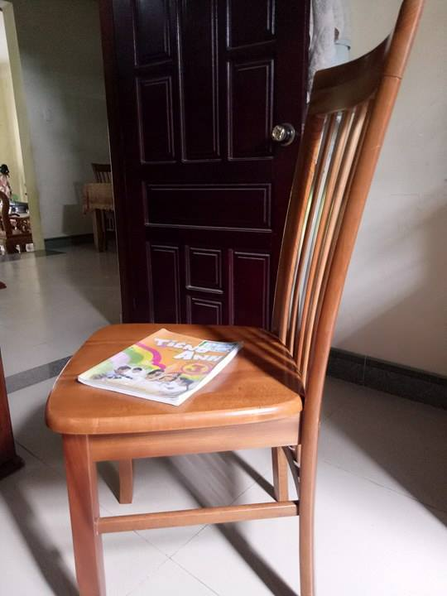 | D   | E  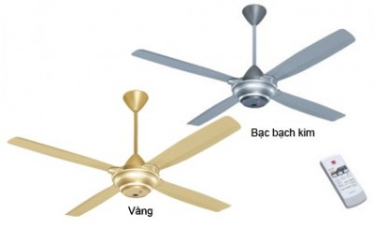
0

Question 2 : Listen and match. There is an example: (1pt)
A.   | B.   | C.  | D.   | E.  

0.Hoa
3. Peter Peter
1.Tony
4.Linda
2.Mai

Question 3: Listen and tick. There is an example: (1 pt)
0.
 |  | 
A. B. C.

1. What are they doing?
A. 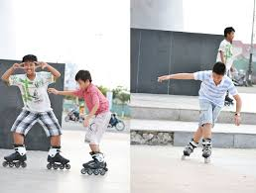 B.  C. 
2.What’s he doing?
A.  B.  C. 
3.Do you have any pets?
A.  B.  C. 
4.What’s the weather like ?
A.  B.  C. 

Question 4: Listen and tick Right or Wrong. There is an example: (1 pt)
Right Wrong
- She’s my mother.

- I have five parrots.

- The boy likes ships.

- Her brother is seventeen years old.

- Nam and Quan are in the park.

Question 5: Listen and complete. There is an example: (1 pt)
- Is there a (0) pond ? Yes, there is.
- There is a (1) …………………..……. It’s very nice!
- I like (2) …………………. days.
- How old is your grandfather? He’s (3)……………………..… years old.
- Where are the cats? They’re (4) ………………… the flower pot.
DAI LOC DEPARTMENT OF EDUCATION & TRAINING  HUA TAO PRIMARY SCHOOL  Full name: …….……………………………  Class: 3………………………… | THE SECOND SEMESTER TEST  Subject: English – Grade: 3  Time: 40 minutes  School year: 2016-2017
Marks: | Comment(s) | Listening | Reading | Writing | Speaking
Part II: Reading and writing. (15minutes).
Question 6: Match the pictures with the words. There is an example: (1 pt)

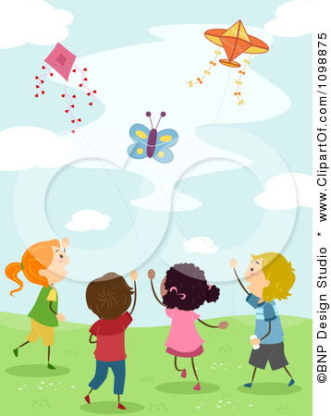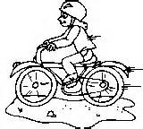
A B C D E

a rabbit | grandfather | a parrot | flying kites | grandmother | rainy | ride a bike

Question 7: Choose a word from the box and write it next to numbers from 1 – 4. There is an example:(1pt)

Mai’s family

Today is Sunday. It’s (0) sunny. Mai’s family is at home. Mai’s father is in the living room . He is (1) ………………… newspaper. Mai’s(2)………………. is in the garden . He’s playing (3) ………………… with his friends. Mai is listening to music in her bedroom. Her mother is in the (4) ……………........ She is cooking. Mai’s family has a nice day.

 | 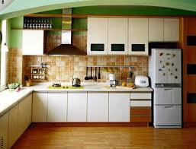 |  |  | 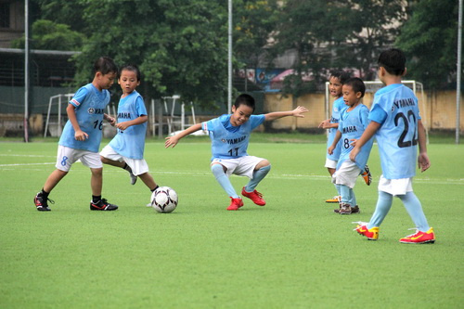 | 
brother | kitchen | sunny | reading | football | swimming

Question 8: Order the letters to make a complete word. There is an example:(1pt)

 | 0. itbbra |  | rabbit
 | 1. paenl |  | _ _ _ _ _
 | 2. oldgishf |  | _ _ _ _ _ _ _ _
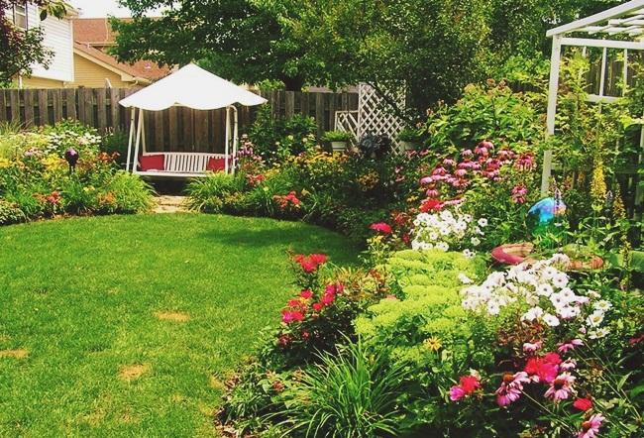 | 3. ragend |  | _ _ _ _ _ _
 | 4. pastorr |  | _ _ _ _ _ _ _
Question 9: Write correct words with pictorial hints. There is an example:(1pt)
- I have three cats. 
- There is a …………………… in my bedroom.
- There is a …………………  around the house.
- Peter has two ……………. . .. .
- The ball’s ………………………………...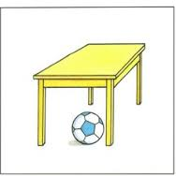 .

Part III: Speaking.(1pt) (5’)

Part III: Speaking. (1pt) (5’)

Part 1: Getting to know each other
The examiner asks 3 questions below:
1.What’s your name?
2.How do you spell your name?
3.How old are you?
Part 2: Talking about a familiar object
The examiner tells the test taker to look at a thing/ things and answer the following questions
1.What’s this?
2.What colour is it?
3.How many chairs/desks/… are there in the class room?

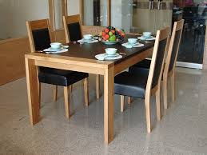

Part 3: Describing the picture
The examiner asks 3 questions below:
- Are there any chairs / …….in the picture?
- Where is the ball in the picture?
- What are the people in the picture doing?
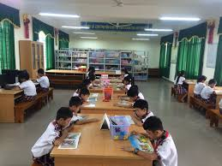

ĐÁP ÁN VÀ BIỂU ĐIỂM
ĐỀ THI TIẾNG ANH 3- HỌC KÌ II
NĂM HỌC: 2016-2017

Part I. Listening (5pts) 20 minutes

Question 1:(1pt) 1. B 2. E 3. C 4. D
Question 2: (1pt)
1. C ( Tony – watching TV)
2. B (Mai- drawing)
3. E (Peter- listening to music )
4.D ( Linda- cooking)

Question 3: (1pt) 1.C 2.A 3.B 4.B
Question 4: (1pt) 1. Right 2. Wrong 3. Wrong 4. Right
Question 5: (1pt) 1. living room 2. rainy
3. sixty-eight 4.next to

Part II. Reading and writing (4pts) 15 minutes

Question 6: (1pt)
A. flying kites B. grandmother C. a rabbit D. ride a bike E. rainy

Question 7: (1pt)
1. reading 2. brother 3. football 4. kitchen

Question 8: :(1pt)
1. plane 2. goldfish 3. garden 4. parrots

Question 9: (1pt)
1.wardrobe 2. fence
3. trucks 4. under the table

Part III: Speaking. (1pt) 5 minutes
Part 1: Getting to know each other
Part 3: Describing the picture
Part 2: Talking about a familiar object

