Name: …………………… **Midterm test 1**

Class: …………………… Time: 40 minutes

1. **Make the stress (’) on the words. (1pts)**
2. village 2. usually 3. underground 4. countryside 5. complete
3. **Look and write: (2pts)**

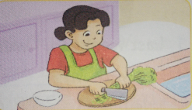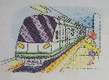

1.Tom often goes to his hometown 2. Mai often ………………dinner

by ………………………………. after school.

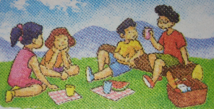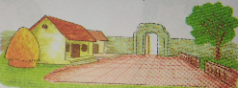

3. Nam will be …………………. 4. We …………………………….

……………………this weekend. last weekend.

1. **Read and match (2,5pts)**

|  |  |
| --- | --- |
| **A** | **B** |
| 1. What do you do in the morning? 2. How often do you visit your grandparents? 3. Where is your hometown? 4. How did you get to your hometown? 5. Where were you yesterday? 6. What did you do last weekend? 7. Where will you be tomorrow? 8. What will you do this weekend? 9. What’s your address? 10. What’s your hometown like? | 1. It’s 65, Hai Ba Trung Street. 2. I swam in the sea. 3. I’ll be in the mountains. 4. It’s small, beautiful and quiet. 5. Twice a month. 6. I’ll fly the kites with my friends. 7. It’s Quang Nam Province. 8. I went there by train. 9. I ride a bike around the park. 10. I was at the zoo. |

1. **Read and complete: (1,5pts)**

|  |
| --- |
| ***cousins province come family village school*** |

My name is Lan. I (1)……………from a small and quiet (2)………………… in the countryside near Cambodia. Now I’m living with my uncle in Quang Nam (3) ……………………….. My new house is near my (4)………………… And I feel happy living with my uncle’s (5)…………………….. My two (6) ………………… and I go to the same school. They are very nice and kind to me.

1. **Put the words in order to make sentences (3pts)**
2. like/ is / What / hometown / your/ ? /

…………………………………………………………………………………

1. to the beach / by / They / coach / went /./

…………………………………………………………………………………

1. do / you / What / last Sunday / did / ? /

…………………………………………………………………………………

1. go / will / Where / weekend / this / you / ? /

…………………………………………………………………………………

1. do / tomorrow / What / will / you / ? /

…………………………………………………………………………………

1. birthday / party / Tony / to / my / I / invited /

…………………………………………………………………………………

Goodluck!