Week: 8 Date of planning: 18/10/2023
Period: 15 Date of teaching: 23/10/2023
UNIT 3 : COLORS
Lesson 1
- Objectives:
By the end of this lesson, students can name the basic colors.
- Teaching aids:
Teacher’s aids: student book and teacher’s book, class CDs, flashcards, IWB software, projector/interactive whiteboard/TV.
Students’ aids: Student books, notebooks, workbooks.
- Languages focus:
Vocabulary: red, yellow, blue
Structure: It’s (red).
- Procedures:
Steps/Activities | Organization
Warm-up: Guessing game: 5’  - Students work in groups.  - Show a half of a picture of a school thing.  - Students work in groups to try to guess what object in the picture is.  - The students who gives a correct guessing will get one point. | - Teacher – whole class/ group work/ individuals
New lesson : 25’  A- Listen and point. Repeat. CD1- Track 38 (8’)  - Use flashcards, crayons or colored pencils to introduce the new words: red, yellow, blue  - Have students listen to each new word.  - Have Ss listen to each new word and repeat all together and individually. Correct S’s pronunciation if it’s necessary.  - Arrange the flashcards on the board. Play audio and have students listen and point to the pictures in their books.  - Play audio again and have Ss listen, repeat several times.  - Change the order of the flashcards, point to them individually and have Ss say the words, correct pronunciation when needed.  - Have students work in pairs, one of them points to the picture in the book and the other says the word.  - Have students hold up their crayons/ colored pencil that is red, yellow or blue and say that color.  Optional activities: (4’)  Pass the card  - Give student a red card.  - Have students listen to music and pass the card. Stop music.  - Have the student with the red card stand up and say ‘red’.  - Change the card and continue the game.  B- Listen and point. CD1- Track 39 (8’)  - Have students look at the picture, identify details (if they can) and colors in the picture.  - Introduce the situation.  - Play audio and have students look at the picture.  - Demonstrate the activity by pointing to the new vocabulary items.  - Play audio. Have students listen and point.  - Have students work in pairs, one point to the color and one say it out loud.  C- Sing. CD1- Track 40 ( 5’)  - Have students turn to page 68.  - Read the lyrics as a whole class.  - Play audio and have students listen.  - Play audio again and have students listen and sing along. | - Teacher – whole class/ individuals  - Teacher-whole class/ groupwork/ individuals  - Teacher-whole class/ individuals/  - Teacher-whole class/ individuals/ pair work
Wrap-up : Read my lips : 5’  - Have two teams set up and the first person on each team must watch the teacher’s mouth.  - Set a word with no voice, just move his/her lips in tongue in the correct way. The first team guess the word correctly gets a point.  - Have students make a sentence with that word. | - Teacher – whole class/ teamwork
Comment:………………………………………………………………………..
…………………………………………………………………………………………………………………………………………………………………………
…………………………………………………………………………………..
****************************************************************
Week: 8 Date of planning: 18/10/2023
Period: 16 Date of teaching: 26/10/2023
UNIT 3: COLORS
Lesson 1
I. Objectives:
By the end of this lesson,
II. Teaching aids:
Teacher’s aids: student book and teacher’s book, class CDs, flashcards, IWB software, projector/interactive whiteboard/TV.
Students’ aids: Student books, notebooks, workbooks.
III. Languages focus:
Vocabulary: red, yellow, blue Structures : It’s (red).
IV. Procedures:
Steps/Activities | Organization
Warm-up: 5’  Option: Clap, jump and hop  - Set a rule about three colors of the previous lesson: Red- clap, Yellow – jump, Blue - hop  - Play the audio of track 40. Have students listen and act out when they hear the color. | - Teacher – whole class
New lesson: 25’  D- Point and say. 8’  - Have students look at the pictures and identify the things. Ask them to tell the colors.  - Divide the class into pairs.  - Have Student A point to the pictures and Student B say, e.g. "It's red." Swap roles and repeat.  - Afterwards, have some pairs demonstrate the activity in front of the class.  Option 1: 4’  - Show a flashcard to the class.  - Have students practice the structure using the new word.  - Repeat with other flashcards. e.g. (Teacher shows flashcard "red.") • Class: "It's red."  Option 2: Guessing game 5’  - Cover some pictures and have students guess.  - Give the correct answers to the students.  - 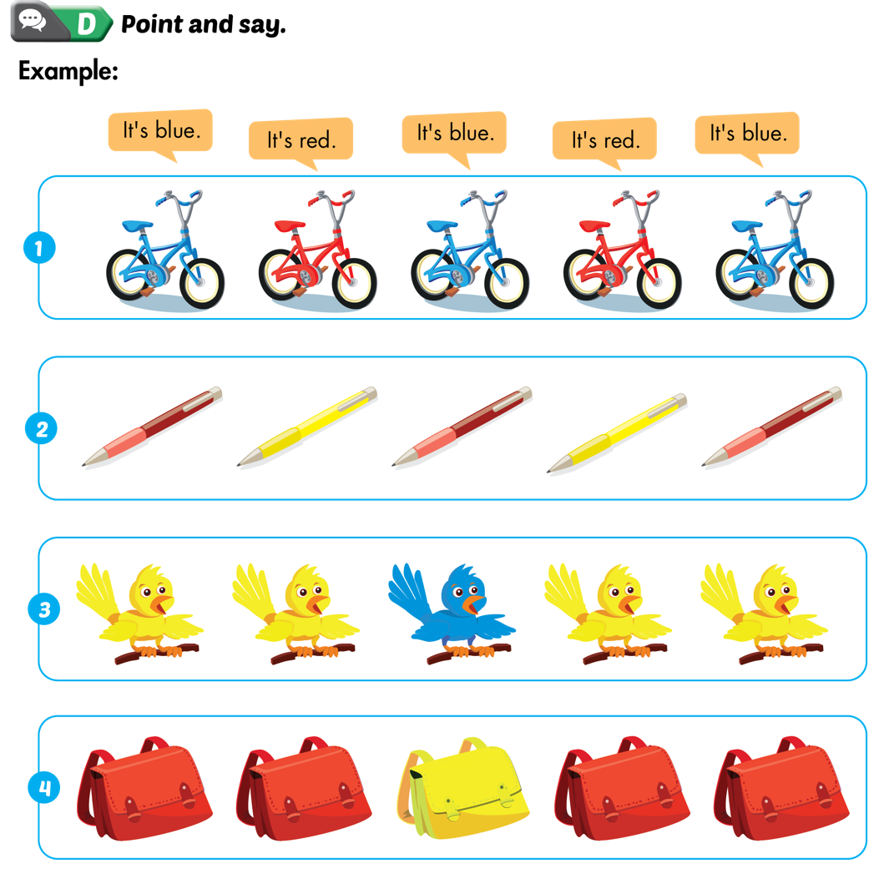  E- Play “ Find the color” 8’  - Have students work in groups of four.  - Have students look at the example.  - Have students take turns coming to the front of the class and give some examples.  - Have the other students try to find objects that are the same color and say the sentence. | - Teacher – whole class/ individuals  - Teacher- whole class/ individuals  - Teacher- whole class/ individuals
Wrap-up: 5’  Option 1: Spelling game  - Divide the class into two teams and play a spelling game. Write the words red, yellow, blue on the board with one of the letters missing. Hold up the relevant card. Children shout out the word and the missing letter.  - Teams take turns. Award a point for each correct answer. | - Teacher – whole class/ teamwork
Comment:………………………………………………………………………………………………………………………………………………………………

