**Name: …………………………. REVIEW TIẾNG ANH 1**

**Class: ………………………… Năm học : 2023-2024**

**PART 1**

1. **Look and write. There is one example.**

|  |  |  |  |  |
| --- | --- | --- | --- | --- |
| Example: | | | | |
|  | 1. **listen** | 1. …………..….. | | 1. ………………… |
|  | 1. ………………… | | 4.………………… | 5………………… |
|  | 6………………… | | 7………………… | 8………………… |
|  | 9………………… | | 10………………… | 11………………… |
|  | 12………………… | | 13………………… | 14………………… |

**PART 2**

**Colour things.**

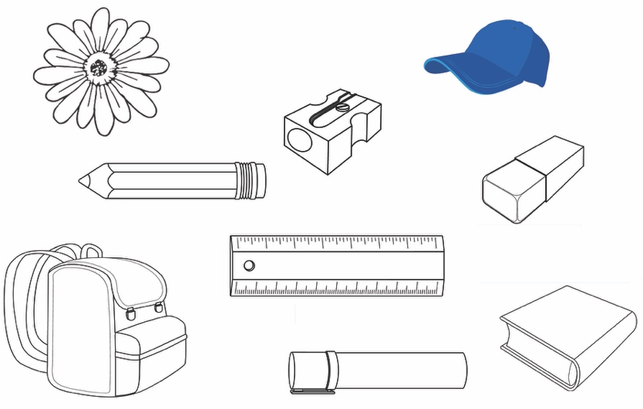

**PART 3 : Read and draw lines. There is one example.**

Listen.

1. This is my mother.

2. It’s a door.

3. I like dogs.



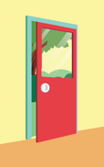

**PART 4**

**Look, read and circle. There is one example.**

|  |  |  |
| --- | --- | --- |
| Example: |  | Goodbye, Kim. |
| 1. | Stand up. | Sit down. |
| 2. | That’s OK. | You’re welcome. |
| 3. | That’s OK. | Nice to meet you. |
| 4. | This is a snake. | This is a bear. |

**PART 5**

**Look, read and put a tick (√) or a cross (×) . There is one example.**

Example:

 Listen. 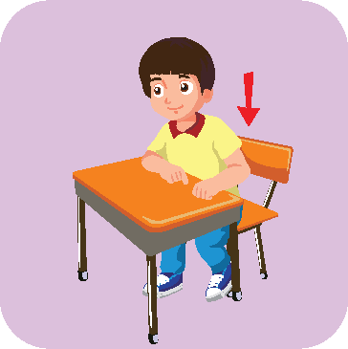 Stand up.

**×**

**√**

|  |  |  |
| --- | --- | --- |
| 1. |  | This is a girl. |
| 2. |  | I like birds. |
| 3. |  | Touch your leg. |

**PART 6**

**Order the letters. There is one example.**

Example

|  |  |  |
| --- | --- | --- |
|  | o b k o | book |
| 1. | a h t e f r | _ _ _ _ _ _ |
| 2. | n e o y m k | _ _ _ _ _ _ |
| 3. | p a h e t e n | _ l _ _ _ _ _ _ |