Week: 22 Date of planning: 14/02/2024
Period: 43 Date of teaching: 15/02/2024
UNIT 7: NUMBERS
Lesson 1
- Objectives: By the end of this lesson, students will be able to count.
- Teaching aids:
Teacher’s aids: student book and teacher’s book, class CDs, flashcards, IWB software, projector/interactive whiteboard/TV.
Students’ aids: Student book, notebooks, workbook.
- Languages focus:
Vocabulary: one, two, three
Structures:
- Procedures:
Steps/Activities | Organization
Warm-up (5’)  - Option 1: Sing and Dance.  Play “I-Learn Smart Start” song (from YouTube) and make gestures following the lyrics, have students stand up and make the gestures  - Option 2: Look and say.  - Go around the class, mime actions (“swim”, “run”, “sing”).  - Have students say “I can swim/ run/ sing”. | - Teacher – whole class  - Teacher - individuals / whole class
New lesson  A- Listen and point. Repeat. (10’)  CD2-Track 10:  - Have students listen to each new word.  - Have students listen to each new word and repeat all together and individually. Correct student’s pronunciation if necessary.  - Arrange the flashcards on the board. Play audio and have students listen and point at the pictures in their books.  - Play audio again and have students listen, repeat several times.  - Change the order of the flashcards, point at them individually and have students say the words, correct pronunciation when needed.  - Have students work in pairs, one points at the picture in the book and the other says the word.  - TPR practice step 1: say the word and make the gesture/ sound all together according to the word.  - TPR practice step 2: do the actions and students say the word accordingly.  - TPR practice step 3: have students work in pairs, one would do the action, the other say the word.  Activities: (optional)  Play the game “Flash look and say”.  - Teacher shows a flashcard quickly.  - Students say that word.  B. Listen and point. (8’)  1. Pre- listening: Introduce the situation, point at each person in the picture and have students call out the words “one, two, three”.  2. While- listening:  - Play audio and have students look at the picture.  - Demonstrate the activity by pointing at "one", "two" , “three” in the picture.  - While-listening: Play the audio again. Have students listen and repeat.  4. While-listening: Play audio again. Have students listen and point.  5. Post- listening: Point at each picture and have students call out the words again “one, two, three.”  - Now, sing a song. (7’)  1. Play audio and have students listen.  2. Play audio and have students turn to page 68.  3. Play audio and have students sing the song as a whole class. | - Teacher – whole class/ individuals/ pair work/ group work  - Teacher – whole class  - Teacher – whole class  - Teacher – whole class
Wrap-up (5’)  Option 2: Review. Play the game “Listen and clap”.  - Teacher says numbers.  - Students clap their hand once if they hear “one”, twice if they hear “two”, and three times-“three”. | - Teacher – whole class/ students
Comment:………………………………………………………………………………………………………………………………………………………………………………..
**********************************
Week: 22 Date of planning: 14/02/2024
Period: 44 Date of teaching: 17/02/2024
UNIT 7: NUMBERS
Lesson 1
I. Objectives: By the end of this lesson, students will be able to count.
II. Teaching aids:
Teacher’s aids: student book and teacher’s book, class CDs, flashcards, IWB software, projector/interactive whiteboard/TV.
Students’ aids: Student book, notebooks, workbook.
III. Languages focus:
Vocabulary: one, two, three
Structures:
IV. Procedures:
Steps/Activities | Organization
New lesson  D- Point and count. (10’)  1. Divide the class into pairs.  2. Demonstrate the activity with a student using numbers “one, two, three” and pointing at the pictures (cat, dog, book..)  3. Have student A point and Student B count.  4. Swap roles and repeat.  5. Check answers as a whole class, then count the objects as a whole class.  6. Have some pairs demonstrate the activity in front of the class.  E- Play “Board race”. (10’)  1. Have students look at the example.  2. Divide the class into teams and have one student from each team stand a distance from the board.  3. Stick two flashcards on the board and then say one of them.  4. Have the students race to the board, touch that flashcard, and say the correct word.  5. The first student to touch the flashcard and say the word gets a point for their team.  6. Continue with other students.  Activity: (5’) (optional)  Call out a number and clap  1. Hold up a flashcard and have students call out the number.  2. Count out loud “One, two, three.” as you clap .  3. Repeat with different numbers and have students call out the number of claps.  4. Say a number and have students count and clap. | - Teacher – whole class  - Teacher – students in pairs  - Teacher - students in groups  - Teacher/ individuals/ Students in pairs
Wrap-up 5’  - Review. Count school items.  - Have each student prepare their school items, e.g. pencil, bag, book… (The number of each school items does not exceed 3).  - Have students work in groups and take turn counting their school items out loud. | - Teacher - students in pairs
Comment:………………………………………………………………………………………………………………………………………………………………………………..
********************************************

Week: 23 Date of planning:18/02/2024
Period: 45 Date of teaching:20/02/2024
UNIT 7: NUMBERS
Lesson 2
- Objectives:
By the end of this lesson, students will be able to recognize the /ɪ/ and /dʒ/ sounds.
- Teaching aids:
Teacher’s aids: student book and teacher’s book, class CDs, flashcards, IWB software, projector/interactive whiteboard/TV.
Students’ aids: Student book, notebooks, workbook.
- Languages focus:
Vocabulary: Ii, Jj, insect, ink, jump, juice
- Procedures:
Steps/Activities | Organization
Warm-up (5’)  - Option 1: write numbers and count things.  - Draw pictures of the same things (but different numbers of things) in different areas of the board, e.g. One picture of two dogs, one picture of three cats, one picture of one bird….  - Have one, two or three students go to the board and write the corresponding number next to each picture, e.g. number 2 next to the picture of two dogs, number 3 next to the picture of three cats…  - Have Class count the animals/ objects in each picture out loud. | - Teacher – whole class
New lesson  The alphabet (5’)  1. Play the alphabet song and have students listen.  2. Play audio again and sing the song.  3. Put the flashcards on the board for the letters in red (i and j).  4. Point to each flashcard, call out the letter's name, and have students repeat.  Letter I  1- Listen and repeat. Trace. (10’)  Listen and repeat:  1. Have students look at the letter.  2. Play audio. Have students listen and repeat all together and individually. Correct student’s pronunciation if necessary.  3. Have some students demonstrate the activity in front of the class.  Trace:  1. Have students call out the letter sound.  2. Demonstrate the steps of tracing the letters with your finger.  3. Have students trace the letters with their fingers.  4. Have some students demonstrate the activity in front of the class.  2- Listen and repeat. (5’)  Listen and repeat:  1. Have students look at the picture, letter and word.  2. Play audio. Have students listen and point to the letter and word as they hear.  3. Have students listen and repeat all together and individually. Correct student’s pronunciation if necessary.  4. Have some students demonstrate the activity in front of the class.  3- Sing. (5’)  1. Have students look at the lyrics and pictures.  2. Read the lyrics as a whole class.  3. Play audio, have students listen and point at the letters/ words.  4. Have students listen and sing along.  5. Have students sing and make a gesture (of an insect).  6. Have some students sing and make the gesture in front of the class. | - Teacher - whole class  - Teacher – whole class/ individuals  - Teacher – whole class/ individuals  - Teacher – whole class/ students
Wrap-up (5’)  4- Listen and clap.  1. Demonstrate the activity.  2. Have students stand up.  3. Have students clap when they hear the 'i' sound.  4. Have some students demonstrate the activity in front of the class. | - Teacher – whole class/ students
Comment: ………………………………………………………………………………………………………………………………………………………………………………………………
*******************************************
Week: 23 Date of planning:18/02/2024
Period: 46 Date of teaching:22/02/2024
UNIT 7: NUMBERS
Lesson 2
I. Objectives:
By the end of this lesson, students will be able to recognize the /ɪ/ and /dʒ/ sounds.
II. Teaching aids:
Teacher’s aids: student book and teacher’s book, class CDs, flashcards, IWB software, projector/interactive whiteboard/TV.
Students’ aids: Student book, notebooks, workbook.
III. Languages focus:
Vocabulary: Ii, Jj, insect, ink, jump, juice
IV. Procedures:
Steps/Activities | Organization
New lesson : Letter J  1- Listen and repeat. Trace. (10’)  Listen and repeat:  1. Have students look at the letter.  2. Play audio. Have students listen and repeat all together and  individually. Correct student’s pronunciation if necessary. | - Teacher – whole class
3. Have some Ss demonstrate the activity in front of the class.  Trace:  1. Have students call out the letter sound.  2. Demonstrate the steps of tracing the letters with your finger.  3. Have students trace the letters with their fingers.  4. Have some Ss demonstrate the activity in front of the class.  2- Listen and repeat. (5’)  Listen and repeat:  1. Have students look at the picture, letter and word.  2. Play audio. Have students listen and point to the letter and word as they hear.  3. Have students listen and repeat all together and individually. Correct student’s pronunciation if necessary.  4. Have some Ss demonstrate the activity in front of the class.  3- Sing. (5’)  1. Have students look at the lyrics and pictures.  2. Read the lyrics as a whole class.  3. Play audio, have Ss listen and point at the letters/words.  4. Have students listen and sing along.  5. Have students sing and make a gesture (jumping).  6. Have some Ss sing and make the gesture in front of the class.  4- Listen and jump. (5’)  1. Demonstrate the activity.  2. Have students stand up.  3. Have students jump when they hear the 'j' sound.  4. Have some Ss demonstrate the activity in front of the class. | - Teacher – students in pairs  - Teacher - students in groups  - Teacher/ individuals/ Students in pairs
Wrap-up  - Option 1: Review. Play the game “Listen and tap”.  - Write the letters and the words in different areas on the board.  - Divide the class into groups.  - Invite a student from each group to go to the board.  - Call out a letter sound or a word.  - The students will run and slap the letter or the word on the board and say it loudly.  - The faster student will be the winner.  - Repeat the activity with other students. | - Teacher - students in groups  - Teacher - student & whole class
Comment: ………………………………………………………………………………………………………………………………………………………………………………………………
****************************************

Week: 24 Date of planning: 24/02/2024
Period: 47 Date of teaching: 26/02/2024
UNIT 7: NUMBERS
Lesson 3
I. Objectives:
By the end of this lesson, students will be able to talk about how old they are.
II. Teaching aids:
Teacher’s aids: student book and teacher’s book, class CDs, flashcards, IWB software, projector/interactive whiteboard/TV.
Students’ aids: Student book, notebooks, workbook.
III. Languages focus:
Vocabulary: four, five, six
Structures: (Vinh)’s (six).
How old are you? I’m (six).
IV. Procedures:
Steps/Activities | Organization
Warm-up (5’)  - Option 3: Clap or Jump.  - Call out a letter sound or a word with that letter.  - Have students stand up and clap if they hear the ‘i’ sound or jump if they hear the ‘j’ sound. | - Teacher – whole class/ students
New lesson: 25’  A- Listen and point. Repeat. (10’) CD2-Track 21:  -Have students listen to each new word.  -Have Ss listen to each new word and repeat all together and individually. Correct student’s pronunciation if necessary.  -Arrange the flashcards on the board. Play audio and have students listen and point at the pictures in their books.  -Play audio again and have Ss listen, repeat several times.  -Change the order of the flashcards, point at them individually and have Ss say the words, correct pronunciation when needed.  -Have students work in pairs, one points at the picture in the book and the other says the word.  -TPR practice step 1: say the word and make the gesture/ sound all together according to the word  -TPR practice step 2: do the actions and students say the word accordingly.  -TPR practice step 3: have students work in pairs, one would do the action, the other say the word.  Activities: (optional)  - Option 1: Play “Heads up. What’s missing”.  1. Play "Heads up. What's missing?"  2. Divide the class into two teams.  3. Arrange the flashcards on the board and remove one card when students are not looking.  4. One student from each team calls out the missing flashcard.  - Option 2: Play the game ‘Pass the flashcard & Name it’  - Give the first student a flashcard and play a song.  - Students have to pass the flashcard.  - When the music stops, the student with the flashcard has to say the word out loud.  - Repeat the activity with other flashcards.  B. (8’)1. Listen and point.  1. Pre- listening: Introduce the situation, point at each person in the picture and have students call out the words “two”, "four", "five", "six".  2. While- listening:  - Play audio and have students look at the picture.  - Demonstrate the activity by pointing at “two”, "four", "five", "six" in the picture.  - While-listening: Play the audio again. Have Ss listen and repeat.  4. While-listening: Play audio again. Have Ss listen and point.  5. Post- listening: Point at each picture and have Ss call out the words again “Binh’s four./Phuong’s five./ Bao’s two….”  6. Post-listening: Have some students demonstrate the activity in front of the class.  2. Listen and repeat.  1. Have students look at the useful language box.  2. Play audio. Have students listen to the useful language.  3. Have students practice the useful language.  4. Have some Ss demonstrate the activity in front of the class.  - Play “Guess the number”. (7’)  1. Have students look at the example.  2. Divide the class into two teams.  3. Have a student stand facing away from the board and stick a flashcard on the board behind them.  4. Have the student try to guess the answer without looking at the flashcard.  5. Give that team one point if it's a correct guess.  6. Have teams take turns. | - Teacher – whole class/ individuals/ pair work/ group work  - Teacher – whole class  - Teacher – whole class/ individuals  - Teacher – whole class/ students  - Teacher – students in groups
Wrap-up (5’)  Option 1: Review. Look and clap.  - Say a number.  - Have students clap their hands the time(s) corresponding to that number.  Option 2: Review. Play “Connect numbers in the right sequence”.  - Put three sets of six numbers (1-6, not in the right sequence) in different areas on the board.  - Have three students go to the board and draw arrows to connect the six numbers in the right sequence (one, two, three, for, five, six).  - Have the class call the numbers in the right sequence out loud.  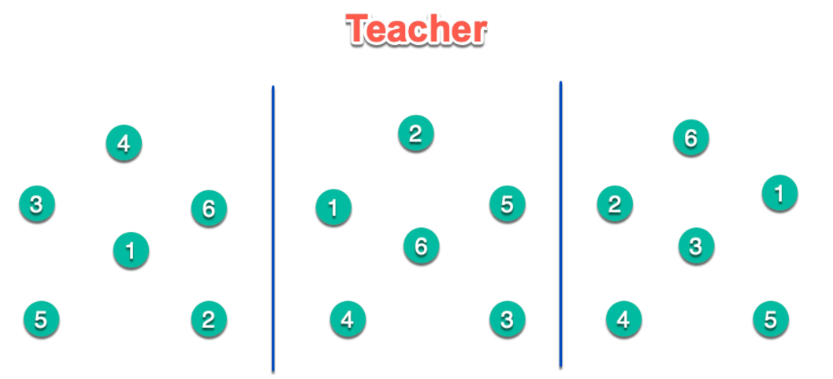  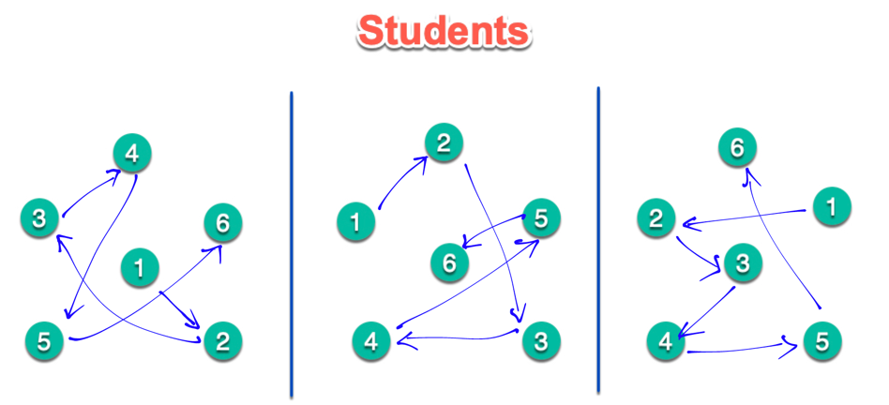 | - Teacher – students in groups  - Teacher – whole class
Comment: ………………………………………………………………………………………………………………………………………………………………………………………………
………………………………………………………………………………………………………………………………………………………………………………………………

******************************************

Week: 24 Date of planning:24/02/2024
Period: 48 Date of teaching:29/02/2024
UNIT 7: NUMBERS
Lesson 3
I. Objectives:
By the end of this lesson, students will be able to talk about how old they are.
II. Teaching aids:
Teacher’s aids: student book and teacher’s book, class CDs, flashcards, IWB software, projector/interactive whiteboard/TV.
Students’ aids: Student book, notebooks, workbook.
III. Languages focus:
Vocabulary: four, five, six
Structures: (Vinh)’s (six).
How old are you? I’m (six).
IV. Procedures:
Time | Steps/Activities | Organization
5’ | Warm-up & Review  (This step can be skipped when periods 1 and 2 are taught in only ONE session.)  - Option 1: Review. What is the missing number?  - Count from 1 to six skipping some numbers.  - Have students say the missing numbers.  - Have some Ss demonstrate the activity in front of the class.  - Start a new activity counting down 6-1 skipping some numbers.  - Option 2: Review. Singing.  - Play the clip “Count to six”. (https://www.youtube.com/watch?v=VK1zbwJrItI)  - Have students sing the numbers they hear. | - Teacher – whole class/ students  - Teacher – whole class
25’ | New lesson  D- 1. Listen to the story. (10’)  1. Pre-listening: Have students look at the picture. Point to each person in the pictures and have students call out the people they see.  2. While-listening:  - Play audio and have students look at the picture and people.  - Demonstrate the activity by pointing at the speech bubbles.  - Have students listen, point and read.  3. Post-listening: Point at each person in the picture and have students say "How old are you?/ I’m five./ I’m six.".  - Listen and repeat: (5')  1. Have students look at the useful language box.  2. Play audio. Have students listen to the useful language.  3. Have students practice the useful language.  4. Have some Ss demonstrate the activity in front of the class.  E – Ask and answer: (5')  1. Divide the class into pairs.  2. Have SA ask and SB answer. Then they swap roles.  3. Have some pairs demonstrate the activity in front of the class.  Practice: (5’) (optional)  Asking your friends’ age.  - Have students go around, say “I’m (six).” and ask their friends “How old are you?”. Have these students answer.  - Have some Ss demonstrate the activity in front of the class. | - Teacher – whole class/ students  - Teacher – whole class/ students  - Teacher - students in pairs  - Students - students
5’ | Wrap-up  - Option 1: Review. Count in row and tell friends your age.  - Have students count in row 1-6. Have the student who says number six stand up and say “I’m six” .  - Option 2: Review. Ask and answer.  - Have students go around the class and ask their friends’ age. Have these friends answer and give more information about their (younger) siblings’’ age, e.g. I’m six. My brother’s five./ My sister’s three. Then swap the roles.  - Option 3:  - Arrange sets of cards on the board. Have students put them in the right sequence (one, two, three, four, five, six).  6  2  4  1  3  5  2  4  5  3  1  6  5  6  3  1  4  2 | - Teacher - students in pairs  - Teacher - whole class
Comment: ………………………………………………………………………………………………………………………………………………………………………………………………
………………………………………………………………………………………………………………………………………………………………………………………………

