Week: 28 Date of planning: 24/03/2024
Period: 55 Date of teaching: 25/03/2024
UNIT 9: TOYS
Lesson 1
- Objectives:
By the end of this lesson, students will be able to say what objects they have.
- Teaching aids:
Teacher’s aids: student book and teacher’s book, class CDs, flashcards, IWB software, projector/interactive whiteboard/TV.
Students’ aids: Student books, notebooks, workbooks.
- Languages focus:
Vocabulary: car, teddy bear, ball
Structure :
- I have a (car).
- Procedures:
Time | Steps/Activities | Organization
5’ | Warm-up  Option 1: Who is faster?  - Divide the class into groups.  - Arrange the flashcards on the board.  - Invite a student from each group to go to the board.  - Teacher says a word and the Ss run to tap the right card.  Option 2: Matching  - Write the vocabulary about numbers 1 to 6 and food on the board.  - Have students read the words on the board.  - Give students flashcards.  - Have students hold the flashcards to match the vocabulary on the board and call out the vocabulary. | - Teacher – whole class/ group work  - Teacher – whole class
25’ | New lesson  A- Listen and point. Repeat. CD 2- Track 39  - Arrange the flashcards on the board, play audio, and point to each flashcard.  - Play audio again and have students point to the pictures in their books.  - Play audio again and have students listen and repeat.  Optional activity 1: Heads up. What's missing?  - Divide the class into two teams.  - Arrange the flashcards on the board and remove one card when students are not looking.  - One student from each team calls out the missing flashcard  B- Listen and point.CD2- Track 40  - Introduce the situation.  - Play audio and have students look at the picture.  - Demonstrate the activity by pointing to the new vocabulary items.  - Play audio. Have students listen and point.  Optional activity 2: Role-play.  - Divide the class into groups of three.  - Have students practice the dialogue.  - Have students make new dialogues by using their real names.  - Have some pairs demonstrate the activity in front of the class.  C- Sing.CD2- Track 41  - Have students turn to page 68.  - Read the lyrics as a whole class.  - Play audio and have students listen.  - Play audio again and have students listen and sing along. | - Teacher – whole class/ individuals  - Teacher-whole class/ groupwork/ individuals  - Teacher-whole class/ individuals  - Teacher-whole class/ groupwork  - Teacher-whole class
5’ | Wrap-up  Option 1: Board race  - Divide the class into two teams.  - Stick three flashcards on the board, e.g. "car", “teddy bear” and "ball".  - Have one student from each team stand away from the board.  - Choose one of the flashcards and say the word.  - Have the students from each team race to the board to  - touch the correct flashcard and say the sentence, e.g. "I have a car."  - The first student to touch the correct flashcard and say the  - sentence will get one point for their team.  - Continue with other students.  - The team with the most points will be the winner.  Option 2: Memory game  - Put up the flashcards on the board.  - Ask the students to memorize the order in which the items appear.  - Remove the flashcards and ask individual students to name the items in the correct order.  - Change the order of the flashcards and repeat the activity. | - Teacher – whole class/ teamwork  - Teacher – whole class/ individuals
Comments:
………………………………………………………………………………………………………………………………………………………………………………………………………………………………………………………………………………………………………
*********************************************************************

Week: 28 Date of planning: 24/03/2024
Period: 56 Date of teaching: 25/03/2024
UNIT 9: TOYS
Lesson 1
- Objectives:
By the end of this lesson, students will be able to say what objects they have.
- Teaching aids:
Teacher’s aids: student book and teacher’s book, class CDs, flashcards, IWB software, projector/interactive whiteboard/TV.
Students’ aids: Student books, notebooks, workbooks.
- Languages focus:
Vocabulary: car, teddy bear, ball
Structures : I have a (car).
- Procedures:
Time | Steps/Activities | Organization
5’ | Warm-up  Option 1: Guessing game  - Students work in groups.  - Show a half of a picture of a toy (car, teddy bear, ball).  - Students work in groups to try to guess what toy in the picture is.  - The students who gives a correct guessing will get one point.  Option 2: Swat the fly.  - Students work in groups. Each group has a fly swatter.  - Place pictures of toys on the board.  - Call out a word.  - Students compete to swat the correct picture and make a sentence about the word they have swatted.  - The winner will get 1 point for his/her group. | - Teacher – whole class/ groupwork  - Teacher-whole class/ groupwork
25’ | New lesson  D- Point and say.  - Have students look at the picture and call out the name of some toys .  - Have students practice the structure using the new word. E.g. "I have a car."  - Have students work in pairs. One points to the toy in the picture and one makes a sentence. Swap roles and continue.  Optional activities  Option 1:  - Invite a child to come to the front of the class and whisper the name of a toy he/she will draw.  - The child draws the picture on the board for the rest of the class to guess what it is.  - The first child to guess the object correctly comes to the front of the class to draw the next picture.  - Repeat until all the toys have been used.  Option 2: Listening line  Draw a line on the floor. On one side of the line write True and on the other side False. Students stand on the line when the teacher hold up a card and says a sentence. E.g. I have a teddy bear. They then stand on the true or false side of the line. If they make a mistake they come back to their seat.  E- Play the “ Chain” game.  - Have students look at the example.  - Divide the class into groups of four.  - Have the students stand up.  - Have Student A turn to Student B and say a sentence, then have Student B say a sentence.  - Next, have Student B turn to Student C and say a sentence, then have Student C say a sentence.  - Continue until all students have practiced.  - Have some groups demonstrate the activity in front of the class | - Teacher – whole class/ pair work  - Teacher- whole class/ individuals  - Teacher- whole class/ individuals  - Teacher- whole class/ groupwork
5’ | Wrap-up  Option 1: Slap  - Split the class into four teams.  - Place pictures of toys on the board.  - Have four students come to the board to face off.  - Call out the word and have students run to the board then slap the pictures. The winner is the team who slaps the pictures first and makes correct sentences that match the vocabulary.  Option 2: : : Missing letters  - Divide the class into four teams.  - Write three words on the board, each missing a letter.  - Have one student from each team come up and try to fill in the missing letters then make sentences with three words given. The first team with the most correct letters and sentences is the winner. | - Teacher – whole class/ teamwork  - Teacher – whole class/ Team work
Comments:
……………………………………………………………………………………………………………………………………………………………………………………………………

Week: 29 Date of planning: 31/03/2024
Period: 57 Date of teaching: 01/04/2024
UNIT 9: TOYS
Lesson 2
I. Objectives:
By the end of this lesson, students will be able to recognize the /m/ sound.
II. Teaching aids:
Teacher’s aids: student book and teacher’s book, class CDs, flashcards, IWB software, projector/interactive whiteboard/TV.
Students’ aids: Student books, notebooks, workbooks.
III. Languages focus: Vocabulary: Mm, mouse, mouth
IV. Procedures:
Time | Steps/Activities | Organization
5’ | Warm-up  Option 1: Sing the alphabet song.  - Play the alphabet song and have students listen.  - Play audio again and sing the song.  - Put the flashcards on the board for the letter m in red.  - Point to each flashcard, call out the letter's name, and have students repeat  Option 2:  - Write the letters of the alphabet on the board and ask children to continue the list from their previous phonics lessons.  - Ask the students to give the words that begin with the letters a to m (ant, boy, … ) from the previous phonics lesson.  - Use phonics cards to prompt if necessary. | - Teacher – whole class  - Teacher – whole class
25’ | New lesson  1. Listen and repeat. Trace. CD2- Track 42  - Play audio. Have students listen and repeat.  - Demonstrate tracing the letters with your finger.  - Have students trace the letters with their fingers. (individuals/ pairs)  - Have some students demonstrate the activity in front of the class.  2. Listen and repeat.CD2- Track 43  - Have students look at the pictures.  - Demonstrate the activity.  - Play audio. Have students point to the letter as they hear it.  - Play audio again. Have students listen and repeat.  - Have some students demonstrate the activity in front of the class.  3. Sing.CD2- Track 44  - Have students look at the lyrics.  - Read the lyrics as a whole class.  - Play audio and have students listen.  - Play audio again and have students listen and sing along.  4. Listen and jump. CD2- Track 45  - Demonstrate the activity.  - Have students stand up.  - Have students jump when they hear the letter sound.  Optional activities:  Option 1: Letter chain  - Place letter cards from A to M on the board.  - Ask one student to say the first letter.  - Ask another student to say the next letter.  - Continue with each student saying the next letter in the sequence, returning to the beginning when necessary.  - Remove one letter. The class repeats the sequence, including the missing letter.  - Remove one more letter each time, until students are saying the whole letters from their memory.  Option 2: Tracing on backs  - Review the previous phonics lesson. Divide the class into groups.  - Have each group make a line, with the first child standing near the board and the last child standing near the back of the classroom.  - Pass out a phonics card to the last child of each line, but don't have them look at the card until you say, Go.  - Have children “Write” the letter very slowly on their classmates’ backs with their fingers.  - The first child goes to the board, writes the letter, and says the sound. The quickest group with the correct letter and pronunciation wins. | - Teacher – whole class/ individuals  - Teacher-whole class/ individuals  - Teacher-whole class/ small groups  - Teacher-whole class  - Teacher – whole class/ individuals  - Teacher – whole class/ groupwork
5’ | Wrap-up  Option 1: Quick flash  - Use the flashcards of letters from a to m.  - Show each card very quickly and then hide it again. Ask the class to call out the words that begin with the hidden letter.  Option 2: Erase the sound  - Write the alphabet from a to m on the board.  - Have one student come to the board.  - Say a sound of a letter and have him/her erase it.  - Continue with the others. | - Teacher – whole class  - Teacher – whole class/ individuals
Comments:
………………………………………………………………………………………………………………………………………………………………………………………………………………………………………………………………………………………………………

Week: 29 Date of planning: 31/03/2024
Period: 58 Date of teaching: 01/04/2024
UNIT 9: TOYS
Lesson 2
I. Objectives:
By the end of this lesson, students will review the /ɪ/ and /dʒ/ sounds.
II. Teaching aids:
Teacher’s aids: student book and teacher’s book, class CDs, flashcards, IWB software, projector/interactive whiteboard/TV.
Students’ aids: Student books, notebooks, workbooks.
III. Languages focus:
Vocabulary:
Structures :
IV. Procedures:
Time | Steps/Activities | Organization
5’ | Warm-up  Option 1: Sing The alphabet song  Have students sing the song with sign language.  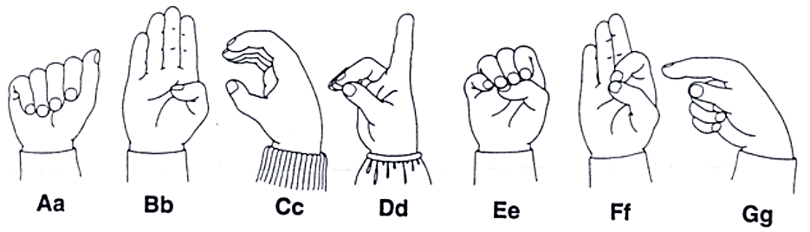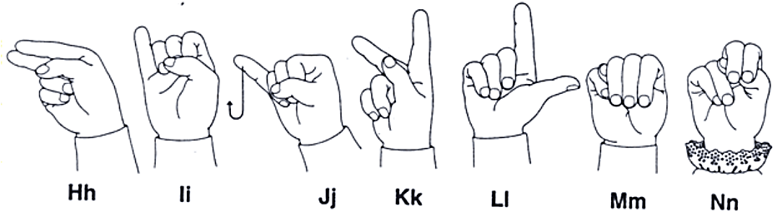  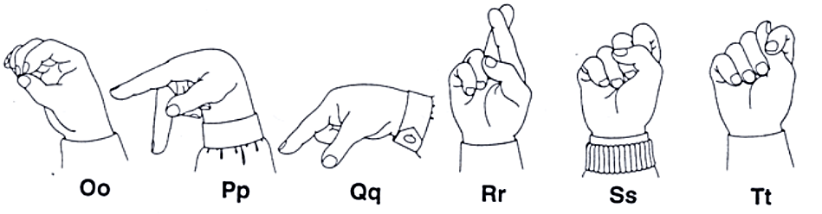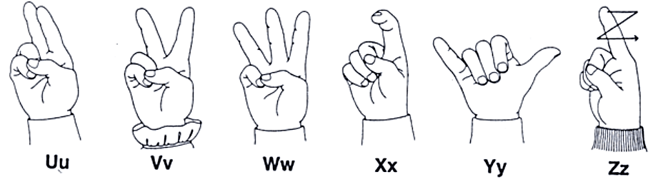  Option 2: Phonics matching  - Display the phonics word cards on the board.  - Place the phonics picture cards on your table.  - Ask children to come to the front of the class to match the cards to the correct sounds on the board. | - Teacher – whole class  - Teacher-whole class/ individuals
25’ | New lesson  1. Listen and repeat.CD2- Track 46  - Have students look at the pictures.  - Point to the pictures and say the letters' sounds.  - Play audio. Have students listen and repeat the letter sounds.  2. Listen and point.CD2- Track 47  - Have students look at the pictures.  - Demonstrate pointing to the correct letter when you hear the sound.  - Play audio. Have students point to the correct picture at the top of the page when they hear the appropriate sound.  3. Write the letter.  - Have Ss look at the pictures and call out the beginning sounds. Demonstrate the activity using the example.  - Have Ss write the letters and say the sound of the letter.  - Check answers as a whole class.  4. Play “ Board race”.  - Have students look at the example.  - Divide the class into teams and have one student from each team stand a distance from the board.  - Write two letters on the board and then say a word beginning with one of their sounds.  - Have the students race to the board, touch that letter, and say the correct sound.  - The first student to touch the letter and say the sound gets a point for their team.  - Continue with other students.  Optional activities  Option 1: Read my lips  - Have two teams set up and the first person on each team must watch the teacher’s mouth.  - Set a letter with no voice, just move his/her lips in tongue in the correct way. The first team to guess correctly gets a point.  Option 2: : Pair race  - Divide the class into two teams, each team has some flashcards of letters i, j and pictures of ink, insect, juice, jump.  - Say Go. Two students of each team take a letter and a picture run to the board. If the letter and picture are matched. They will have one point.  - Continue the game as the same way. | - Teacher – whole class/ individuals  - Teacher- whole class/ individuals  - Teacher- whole class/ individuals  - Teacher- whole class/ teamwork  - Teacher- whole class/  teamwork  - Teacher- whole class/  teamwork
5’ | Wrap-up  Option 1: Phonics posters  - Divide the class into groups of five.  - Hand out sheets of paper and colored pencils.  - Children choose the “J”, “K” sound.  - They must draw pictures of one or two words with their chosen sound and color them. Somewhere on the poster they should write the sound.  - Put the phonics posters around the classroom.  Option 2: Patty Cake  - Divide the class into pairs.  - Have children sit facing each other. Children slap their knees once, clap their hands once, and then clap their partner’s hands once as they both say /i/ ,/i/ , insect,….  - Children repeat the action, this time saying /j/ /j/ juice,…..  - Continue doing the action for each of the two letters and words. | - Teacher – whole class/ teamwork  - Teacher – whole class/ pair work
Comments:………………………………………………………………………………………………………………………………………………………………………………………

Week: 30 Date of planning: 07/04/20L4
Period: 59 Date of teaching: 08/04/2024
UNIT 9: TOYS
Lesson 3
- Objectives:
By the end of this lesson, students will be able to ask and answer about numbers of objects.
- Teaching aids:
Teacher’s aids: student book and teacher’s book, class CDs, flashcards, IWB software, projector/interactive whiteboard/TV.
Students’ aids: Student books, notebooks, workbooks.
- Languages focus:
Vocabulary: seven, eight, nine, ten
Structure : (Ten) (teddy bears)
- Procedures:

Time | Steps/Activities | Organization
5’ | Warm-up  - Song: sing the alphabet song  - Musical cards  - Play some lively music.  - Hand out the flashcards from the previous lesson.  - Children pass the flashcards around all the rows of seats while the music is playing.  - Stop the music suddenly. Ask the children who are holding the flashcards to stand up and say the word. E.g. “one.”  - Play the music and continue in the same way. | - Teacher – whole class
25’ | New lesson  A- Listen and point. Repeat.CD2- Track 48  - Arrange the flashcards on the board, play audio and point to each flashcard.  - Play audio again and have students point to the pictures in their books.  - Play audio again and have students listen and repeat.  - Play "Guess."  - Arrange the flashcards on the board and write a number under each card.  - Have students look at the flashcards for the count of ten. Turn the flashcards over to face the board when the students are not looking. Call out a number and have students take turns to guess the face-down card. Turn the card over after each guess.  B- 1.Listen and point.CD2- Track 49  - Have students call out the things they can see.  - Have them count the cars, balls and teddy bears.  - Have students listen and follow.  - Play audio and demonstrate pointing.  - Play audio. Have students listen and point.  2. Listen and repeat.CD2- Track 50  - Have students look at the useful language box.  - Play audio. Have students listen to the useful language.  - Have students practice the useful language.  C- Point and say.  - Have students look at the pictures and identify the things they see.  - Divide the class into pairs.  - Have Student A point to the pictures and Student B say, e.g. "seven books."  - Swap roles and repeat.  - Have some pairs demonstrate the activity in front of the class.  Optional activities:  Option 1: Count the objects  - Have students take out their school objects and have them work in pairs. Student A points to the objects he/she has and say the quantity.  - Swap roles and continue.  Option 2: Run and draw.  - Have students work in four teams.  - Stick four blank sheets on the board.  - Say “ Draw four books.” Have one student of each team run to the board to draw what the teacher said.  - Continue the game in the same way.  - The winner is the team who has the most correct pictures. | - Teacher-whole class/ groupwork/ individuals  - Teacher-whole class/ individuals  - Teacher-whole class  - Teacher-whole class/ pair work  - Teacher-whole class/ pair work  - Teacher-whole class/ teamwork
5’ | Wrap-up  Option 1: Pass the envelope  - Divide the class into groups.  - Give each group an envelope with the word cards inside. E.g. “ five books, ten cars….”  - Play a song as background music. Children pass the envelope to a classmate as the music plays.  - Stop the music randomly. The student holding the envelope opens it and takes out one card then read it aloud.  - Continue the game until there are no more cards left in the envelope.  Option 2: Find the objects  - Hide some school things and toys at many places in the classroom.  - Have students go around, find and count the objects. | - Teacher – whole class/ groupwork/ individuals  - Teacher – whole class/ teamwork
Comment:
……………………………………………………………………………………………………………………………………………………………………………………

Week: 30 Date of planning: 07/04/2024
Period: 60 Date of teaching: 08/04/2204
UNIT 9: TOYS
Lesson 3
- Objectives:
By the end of this lesson, students will be able to ask and answer about numbers of objects.
- Teaching aids:
Teacher’s aids: student book and teacher’s book, class CDs, flashcards, IWB software, projector/interactive whiteboard/TV.
Students’ aids: Student books, notebooks, workbooks.
- Languages focus:
Vocabulary: seven, eight, nine, ten
Structures : (Ten) (teddy bears)
How many (cars)? (Seven) (cars).
- Procedures:

Time | Steps/Activities |  | Organization
5’ | Warm-up  Option 2: Feely Bag  - Put some pictures in a box.  - Play some music and ask children to pass the box from one child to the next around the circle.  - Stop the music suddenly. The child who has the box when the music stops feels a picture in the box and says “ seven books.” Then the child pulls the picture out of the box to see if he/she was correct.  - Play the music and continue in this way until several children have had a turn. | - Teacher-whole class/ individuals
25’ | New lesson  D-1. Listen to the story.CD2- Track 50  - Have students call out the things they can see.  - Introduce the situation: “ Vinh and Bobby are playing. Vinh asks: How many cars? And Bobby answers: Seven cars.”  - Play audio and have students listen and read.  2. Listen and repeat.  - Have students look at the useful language box.  - Play audio. Have students listen to the useful language.  - Have students work in pairs, practicing the useful language.  Optional activity 1: Role-play  Have students work in pairs and act out the story.  E- Play” Count the objects”  - Have students look at the pictures and call out the things they see.  - Divide the class into pairs.  - Have Student A ask and Student B answer.  - Swap roles and repeat.  - Have some pairs demonstrate the activity in front of the class.  Optional activity 2:  - Have students take out their school things, count the things they have and work in pairs. Student A asks and student B answers the question.  - Swap roles and continue. | - Teacher – whole class/ individuals  - Teacher- whole class/ pair work  - Teacher- whole class/ pair work
5’ | Wrap-up  Option 1: Unscramble the sentence.  balls  many  ?  How  balls  Six  .  ?  cars  many  How  Nine  cars  .  - Have students work in groups of four.  - Give each groups some flash cards, each card has a word on it.  - Set up a limit time.  - Have students arrange words to make sentences. There are four sentences for each group.  - Have students in each group give their ideas about the tasks.  - Teacher gives correct answers.  Option 2: Running dictation  - Stick some pictures (one bag, nine teddy bears, ten cars, eight balls) on the walls in the class.  - Have students work in pairs. One runs and find the pictures around him/ her, then turn back to his pair and tell what he/ she has seen. E. g One bag. His/ Her friend writes down the word he/ she has heard. |  | - Teacher – whole class/ teamwork  - Teacher – whole class/ pair work

Comment:
……………………………………………………………………………………………………………………………………………………………………………………

