**Week: 26** Date of planning: 10/03/2024

**Period: 103**  Date of teaching: 14/03/2024

**REVIEW 3**

**I. Objectives:** By the end of this unit pupils can

- Listen and identify specific information related to the theme: Me and my family.

- Read and identify specific information related to the theme: Me and my family.

- Use simple sentences to write about themselves.

- Listen and tick the correct pictures.

- Listen and number the pictures.

- Listen and write one word in the blank.

- Read the paragraph and complete the table.

- Write about themselves, using the guiding questions.

**II. Language focus**

**-** Vocabulary: Unit 11 - 15

**-** Sentence patterns: Unit 11 - 15

**III. Teaching aids**

1. Teacher’s: student’s and teacher’s book, pictures, cassette.

2. Students’: books, notebooks, workbooks.

**IV. Procedures**

|  |  |  |
| --- | --- | --- |
| **Content** | **Teacher’ s activities** | **Student’s activities** |
| **A. Warm up**  (5’)  **B. New lesson**  (25’)  **C. Production**  (3’)  **D. Homework**  (2’) | *-* Ask pupils tochant: *What would you like to be in the future?*  *Task 1. Listen and tick****. (9’)***  ***-*** Ask pupils to identify each character and what’s the matter with him/ her or what he/she is doing.  - Tell pupils that they are going to listen to the recording and write the correct pictures.  - Play the recording all the way through for pupils to listen.  - Play the second time and ask pupils to do the task.  - Ask pupils to give answers  - Play the recording again for pupils to listen and check  - Give correct answers.  ***\* Key:*** *1. b 2. c*  *Task 2. Listen and number (8’)*  - Tell pupils that they are going to listen and number the pictures in the order they here.  - Play the recording two times for pupils to listen.  - Play it again for them to number the pictures.  - Get pupils to compare their answers before checking as a class.  - Give answers.  * **Key:** *a 2 b 1 c 4 d 3*  *Task 3. Listen and write one word in the blank (8’)*  ***-*** Tell pupils that they are going to listen and write one word in each gap.  - Ask pupils toread the sentences in silence in their book and guess the answers based on the surrounding words.  - Play the recording the first time all the way through for pupils to listen and write.  - Play it the second time for pupils to listen and check their answers.  - Give the correct answers.  * Key: 1 *design 2 reading*  *Task 4. Read and complete. (10’)*  - Tell pupils that they are going to read the text and complete the table.  - Give pupils time to look at the table in theirs book and think of the information needed to fill the gaps.  - Ask pupils to read the text in silence and complete the table.  - Get pupils to compare their answers in pairs before checking as a class.  - Give explanations, if necessary.  * Key:  *1. pilot*  *2. wants to fly planes*  *3. reads books*  *4. would like to write stories for children*  *5. draws pictures*  *Task 5. Write about you (10’)*  ***-*** Tell pupils that they are going to write sentences about themselves.  - Give them time to read the questions in silence, then complete the sentences about themselves.  - Call three pupils to read the answers aloud in front of the class. Ask others to listen and give comments.  - Give feedback.  ***\*. Do exercise in workbook (5’)***  - Summary the lesson  - Ask pupils to do exercises in workbook. | - Let’s chant  - Look at the pictures  - Listen to the recording.  - Listen to the recording and do the task.  - Give answers  - Listen and check.  - Listen to T.  - Listen to the recording  - Number the pictures.  - Compare the answers.  - Read the sentences in silence and guess the answers.  - Listen and wirte  - Listen and check  - Look at the book  - Read the text in silence and complete the table.  - Compare the answers in pairs  - Read the questions in silence and complete the sentences.  - Read the answers aloud  - Take note |

**Comment:**

**………………………………………………………………………………………………………………………………………………………………………………………………………………………………………………………………………………**

**Week: 26** Date of planning: 17/03/2024

**Period: 104**  Date of teaching: 19/03/2024

**SHORT STORY**

**CAT AND MOUSE 3**

**I. Objectives:** By the end of this unit pupils can:

- Read and listen to the short story.

- Answer the questions.

- Unscramble the words from the story.

- Read and complete the conversation.

- Work in pairs. Imagine they are sick. Talk about how they feel.

- Read and match the questions with the answers.

**II. Language focus**

- Vocabulary: Unit 11 - 15

- Sentence patterns: Unit 11 - 15

**III. Teaching aids**

1. Teacher’s: student’s and teacher’s book, pictures, cassette.

2. Students’: books, notebooks, workbooks.

**IV. Procedures**

|  |  |  |
| --- | --- | --- |
| **Content** | **Teacher’s activities** | **Student ‘s activities** |
| **A. Warm up**  (5’)    **B. New lesson**  (30’)  **C. Production**  (3’)  **D. Homework**  (2’) | *Task 1. Read and listen to the story*  - Tell the class that they are going to read and listen to the story.  - Ask pupils to look at the pictures and ask them question:  *Where are Chit and Miu? What’s the matter with Miu? What’s Miu going to do with Maurice and Doris? Where’s Mauris? What’s the matter with him?*  - Play the recording three times for pupils to listen and follow in their books.  - Play it again for them to listen and repeat  - Then ask them to practice the conversation in groups of three.  - Call on some groups to practice the dialogue.  - Give feedback.  *Task 2. Answer the questions*  - Tell pupils that they are going to answer the questions about the story.  - Give them time to look at the story again, then read the questions and answer them in pairs.  - Invite some pairs to ask and answers aloud.  *Key:  *1. No, he isn’t.*  *2. He has a headache, a stomach ache and a fever.*  *3. He’s going to the zoo with Maurice and Doris.*  *4. No, they can’t.*  *5. He can stay in bed.*  *Task 3. Unscramble these words from the story*  - Tell pupils that they are going to put the letters in the correct order and write the words from the conversation in Activity 1.  - Give them time to do the task. Give the first letters of the words, if necessary.  - Call some pupils to go to the board and write their answers  - Give correct answers  Key: a. headache d. because  b. terrible e. matter c. speaking  *Task 4. Read and complete*  - Tell pupils that they are going to read and complete the gapped sentences.  - Give them a few seconds to read the conversation in silence.  - Set a time limit for them to do the task. Tell them to read the story again if they do not know the answers.  - Give correct answers  * Key:  *1. well 2. matter 3. have*  *4. stay 5. not*  *Task 5. Work in pair. Talk about how you feel*  - Tell pupils that they are going to practice talking about how they feel when they are sick.  - Give them time to do the task in pairs.  - Invite a few pairs to act out the dialogues. Correct the pronunciation, if necessary  *Task 6. Read and match*  - Tell the class that they are going to read and match the questions with the answers.  - Ask pupils to do the task in silent.  - Call two pupils to write their answers on the board.  - Ask pupils to swap and check their answers.  * Key: *1.e 2.a 3.b 4.c 5.d*  - Summary the lesson  - Ask pupils to do exercises in workbook. | - Answers the questions  - Listen, and follow in the book  - Listen and repeat  *-* Work in groups  *-* Practice the dialogue  - Work in pairs  - Ask and answer in front of class  - Do the task  - Write the answers on the board  - Read the conversation in silence.  - Do the task.  - Listen to the Teacher.  - Work in pairs  - Act out the dialogues  - Do the task in silent  - Write the answers on the board  - Swap and check the answers.  - Listen  - Take note |

**Week: 27** Date of planning: 17/03/2024

**Period: 104**  Date of teaching: 19/03/2024

**TEST 3**

**Task 1. *Choose the correct answer:* (1,25 points)**

1. I think Tam is _______. A. greedy B. kind C. ugly D. stupid
2. The main character in *Snow White* is _______.

A. the princess B. Snow White C. Doraemon D. Tom

1. Trung would like to be a _______ in the future.

A. pilot B. engineer C. artist D. architect

1. Why would you like to be a nurse? - _______.

A. Because I would like to look after the patients.

B. Because I would like to teach the children.

C. Because I would like to write stories for children.

D. Because I would like to fly a plane.

1. Don’t ride your _____ so fast! A. car B. matches C. bike D. stairs

**Task 2. Look and read. Put a tick (✓) or a cross (x). (1,25 points)**

|  |  |  |
| --- | --- | --- |
| 1. Don’t play with the matches. | knife |  |
| 1. He has a fever. | fever |  |
| 1. I’m reading the Story of Mai An Tiem. | snow white |  |
| 1. I’d like to be an architect because I’d like to design buildings. | kien truc su |  |
| 1. Phong and Nam often go fishing in their free time. | cau ca |  |

**Task 3. Look and write the correct words. (1,25 points)**

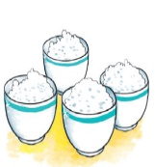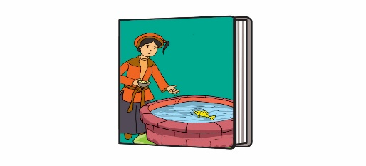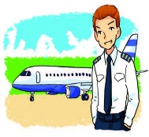

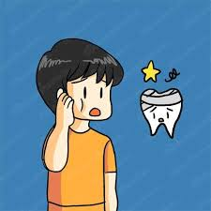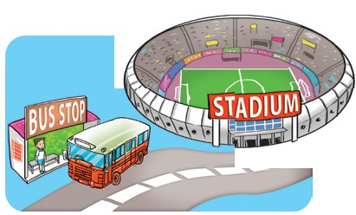

***toothache bus stop pilot rice The story of Tam and Cam***

1. It’s a fairy tale about two sisters. ..…………………….
2. He has a pain in her tooth. ..…………………….
3. A person who flies or is qualified to fly an aircraft or spacecraft. ..…………………….
4. A Southeast Asian grass widely grown in warm wet areas

especially for its seeds which are used for food. ..…………………….

1. A place where a bus regularly stops, usually marked by a sign. ..…………………….

**Task 4: Read and answer the questions. (1 point)**

Hi, I’m Mai. My hobby is reading folk tales. Folk tales are usually short and interesting. They often give me one surprise after another. The characters are sometimes honest, sometimes greedy, sometimes wise, and sometimes stupid. I like The Fox and the Crow very much. The Fox was clever and the Crow was not. The Crow lost its delicious meat and the Fox got it. I love folk tales very much because each of them gives me a lesson in life.

1. What kinds of stories does Mai like reading?

…………………………………………………………………………………………..

1. What does she think of folk tales?

…………………………………………………………………………………………..

1. What does she think of the characters in folk tales?

…………………………………………………………………………………………..

1. What does she think of the characters in The Fox and the Crow?

…………………………………………………………………………………………..

**Task 5: Reorder the words to make sentences (1, 5 points)**

1. knife./ sharp/ play/ that/ with/ Don’t

…………………………………………………………………………………………..

1. do/ brother/ What/ free/ in/ his/ does/ your/ time?

…………………………………………………………………………………………..

1. Phu Quoc/ I/ to/ Island./ went

…………………………………………………………………………………………..

1. fly/ because/ be/ would like/ Minh/ pilot/ to/ planes./ like/ he’d/ a/ to

…………………………………………………………………………………………..

1. Tam/ gentle./ beautiful/ and/ was

…………………………………………………………………………………………..

1. you / what / doing / are / stove / with / the / ?

…………………………………………………………………………………………..

*********Goodluck!*********