Week: 25 Date of planning: 03/3/2024
Period:49 Date of teaching: 04/3/2024
UNIT 8: FOOD
Lesson 1
- Objectives:
By the end of this lesson, students will be able to say what food they want.
- Teaching aids:
Teacher’s aids: student book and teacher’s book, class CDs, flashcards, IWB software, projector/interactive whiteboard/TV.
Students’ aids: Student books, notebooks, workbooks.
- Languages focus:
Vocabulary: banana, cookie, sandwich
Structure : I want a (banana).
- Procedures:
Steps/Activities | Organization
Warm-up: 5’  Option 1: Pass the balls  - Give two different colored balls to two students, a red ball (ask the question) and a yellow ball (answer the question).  - Have students listen to music and pass the balls.  - Stop music.  - Have the student with a red ball make a question for the child who has yellow ball. E. How old are you? The child with the yellow ball will answer his/ her friend’s question. E. g. I’m (seven).  Option 2: Conversation Lines  - Have students stand in parallel lines facing each other.  - Have students work in pairs.  - Student A asks: “How old are you?”  - Student B answers: “I’m (seven). | - Teacher – whole class/ pair work  - Teacher – whole class/ pair work
New lesson: 25’  A- Listen and point. Repeat.CD2- Track 26 5’  - Arrange the flashcards on the board, play audio and point to each flashcard. Have students listen.  - Play audio again and have students point to the pictures in their books.  - Play audio again and have students listen and repeat.  - Have one student go to the board and play the role of a teacher, point to the picture and have the others repeat.  Optional activities: 4’  Option 1: Heads up. What's missing?  - Divide the class into two teams.  - Arrange the flashcards on the board and remove one card when students are not looking.  - One student from each team calls out the missing flashcard.  Option 2: Flyswatter 4’  - Write “banana, cookie, sandwich” on the board.  - Divide the class into four teams. Have one student from each team come to the board holding a flyswatter.  - Read a word aloud, e.g. “banana” . Have students race to the board and hit the word with the flyswatter. The winner is the one who hits the correct word first.  - Play until everyone in the class has had at least one turn.  B- Listen and point.CD2- Track 27 7’  - Introduce the situation: The family are at the park. Ben says, “ I want a cookie.”  - Play audio and have students look at the picture.  - Play audio. Have students listen and repeat.  - Demonstrate the activity by pointing to the new vocabulary items.  - Play audio. Have students listen and point.  - Have students work in pairs. Student A says, “I want (a cookie).” Student B says, “Me too”. or “I want (a sandwich).”  C- Sing.CD2- Track 28 5’  - Have students turn to page 68.  - Read the lyrics as a whole class.  - Play audio and have students listen.  - Play audio again and have students listen and sing along. | - Teacher – whole class/ individuals  - Teacher-whole class/ teamwork  - Teacher-whole class/ teamwork  - Teacher-whole class/ individuals/pair work  - Teacher-whole class
Wrap-up : 5’  Option 1: Feely Bag  - Put some pictures in a bag.  - Have children sit in a circle.  - Play some music and ask children to pass the bag from one child to the next around the circle.  - Stop the music suddenly. The child who has the bag when the music stops feels a picture in the bag and says “ I want a (cookie).” Then the child pulls the picture out of the bag to see if he/she was correct.  - Play the music and continue in this way until several children have had a turn.  Option 2: Missing letters  - Divide the class into three teams.  - Write three words on the board, each missing a letter.  - Have one student from each team come up and try to fill in the missing letters then make sentences with three words given. The first team with the most correct letters and sentences is the winner. | - Teacher – whole class/ individuals  - Teacher – whole class/ teamwork
Comment: …………………………………………………………………………………………………………………………………………………………………………………………
…………………………………………………………………………………………………………………………………………………………………………………………

Week: 25 Date of teaching:03/3/2024
Period: 50 Date of teaching:07/3/2024
UNIT 8: FOOD
Lesson 1
- Objectives:
By the end of this lesson, students will be able to say what food they want.
- Teaching aids:
Teacher’s aids: student book and teacher’s book, class CDs, flashcards, IWB software, projector/interactive whiteboard/TV.
Students’ aids: Student books, notebooks, workbooks.
- Languages focus:
Vocabulary: banana, cookie, sandwich
Structures : I want a (banana).
- Procedures:
Steps/Activities | Organization
Warm-up : 5’  Option 1: Whisper  - Arrange children into rows of at least six.  - Secretly show a flashcard to the first child in each group. This child whispers the word to the child next to him/her.  - Children continue whispering the word to the child next to them until the word reaches the final child.  Option 2: Guessing game.  - Divide the class into small groups.  - Show a half of a picture of a banana (cookie /sandwich).  - Students in each group try to guess what food in the picture is.  - The student who gives a correct answer will get one point. | - Teacher – whole class/ groupwork  - Teacher-whole class/ groupwork
New lesson : 25’  D- Point and say. 5’  - Have students look at the pictures and identify the food.  - Divide the class into pairs.  - Have Student A point to the pictures and Student B say, e.g. "I want a cookie." Swap roles and repeat.  - Afterwards, have some pairs demonstrate the activity in front of the class.  Optional activities 8’  Option 1:  - Show a flashcard to the class.  - Have students practice the structure using the new word.  - Repeat with other flashcards. e.g.(Teacher shows flashcard "cookie.") • Class: "I want a cookie."  Option 2:  - Divide the class into pairs.  - Have Student A point to the picture and Student B say, e.g. "I want a cookie."  - Swap roles and repeat.  - Have some pairs demonstrate the activity in front of the class.  E- Play “ Board race” 7’  - Have students look at the example.  - Divide the class into four teams and have one student from each team stand a distance from the board.  - Stick two flashcards on the board and then say one of them.  - Have the students race to the board, touch that flashcard, and say the correct sentence.  - The first student to touch the flashcard and say the sentence gets a point for their team.  - Stick three flashcards on the board and continue the game with other students.  Extra activity: Hold up your pictures! 5’  - Have students draw a banana, a cookie or a sandwich in a piece of paper (size A5)  - Play audio ( track 28) and have students sing this song. Ask the children to hold their pictures that match the lyric. | - Teacher – whole class/ pair work /individuals  - Teacher- whole class/ individuals  - Teacher- whole class/ pair work  - Teacher – whole class/ teamwork  - Teacher – whole class
Wrap-up 5’  Option 1: True or False” Line.  - Put a line of tape on the floor and designate one side "True" and the other "False".  - Hold up an object or flashcard and say its word ( or a sentence). If students think the word ( a sentence) you have said is the correct word, they jump to the “True” side. And if not, they jump to the “False” side.  - Students that jump to the wrong side are out of the game and sit down.  Option 2: : Pass the card  - Give student a flashcard.  - Have students listen to music and pass the flashcard.  - Stop music.  - Have the student with the flashcard stand up and say ‘I want a (cookie)’.  - Change the card and continue the game. | - Teacher – whole class  - Teacher – whole class/ individuals
Comment: …………………………………………………………………………………………………………………………………………………………………………………………
…………………………………………………………………………………………………………………………………………………………………………………………
***************************************
Week:26 Date of planning: 12/03/2022
Period: 51 Date of teaching: 14/03/2022
UNIT 8: FOOD
Lesson 2
- Objectives:
By the end of this lesson, students will be able to recognize the /k/ and /l/ sounds.
- Teaching aids:
Teacher’s aids: student book and teacher’s book, class CDs, flashcards, IWB software, projector/interactive whiteboard/TV.
Students’ aids: Student books, notebooks, workbooks.
- Languages focus:
Vocabulary: Letter Kk, Ll , kick, kite, love, leaf
- Procedures:
Steps/Activities | Organization
Warm-up : 5’  Option 1: Sing The alphabet song  - Play the alphabet song and have students listen.  - Play audio again and sing the song.  - Put the flashcards on the board for the letters in red (k and l). Point to each flashcard, call out the letter's name, and have students repeat.  Option 2: Mystery bag  - Place toys ( ant, elephant, leaf,..) and pictures ( cap, door,…) within a bag—like ant for a, boy for b,….  - Have students name each toy or card, and guess the “mystery letter”. | - Teacher – whole class/ groupwork/ individuals  - Teacher – whole class
New lesson: 25’  1. Listen and repeat. Trace. CD 2- Track 29 5’  - Play audio. Have students listen and repeat.  - Demonstrate tracing the letters with your finger.  - Have students trace the letters with their fingers.  - Have some Ss demonstrate the activity in front of the class.  2. Listen and repeat. CD 2- Track 29 5’  - Have students look at the pictures.  - Demonstrate the activity.  - Play audio. Have students point to the letter as they hear it.  - Play audio again. Have students listen and repeat.  - Have some students demonstrate in front of the class.  3. Sing.CD 2- Track 31 5’  - Have students look at the lyrics.  - Read the lyrics as a whole class.  - Play audio and have students listen.  - Play audio again and have students listen and sing along.  4. Listen and hop. CD 2- Track 32 5’  - Demonstrate the activity.  - Have students stand up.  - Have students hop when they hear the letter sound.  Optional activities: 5’  Option 1: Tracing on backs  - Divide the class into groups.  - Have each group make a line, with the first child standing near the board and the last child standing near the back of the classroom.  - Pass out a phonics card to the last child of each line, but don't have them look at the card until you say, Go.  - Have children “Write” the letter very slowly on their classmates’ backs with their fingers.  - The first child goes to the board says the sound. The quickest group with the correct pronunciation wins.  Option 2: Pair race  - Divide the class into two teams, each team has some flashcards of letters k, l and pictures of kick, kite, love, leaf.  - Say Go. Two students of each team take a letter and a picture run to the board. If the letter and picture are matched. They will have one point.  - Continue the game as the same way. | - Teacher – whole class/ individuals  - Teacher-whole class/ individuals  - Teacher-whole class  - Teacher-whole class  - Teacher-whole class/ groupwork  - Teacher-whole class/ pair work
Wrap-up: 5’  Option 1: Listen and tap  - Write the letters and the words in different areas on the board.  - Divide the class into groups.  - Invite a student from each group to go to the board.  - Call out a letter sound or a word.  - The students will run and slap the letter or the word on the board and say it loudly.  - The fastest student will be the winner.  - Repeat the activity with other students.  Option 2: Alphabet ball  - Have students make a big circle.  - Give a ball to the first student and ask he/she to say a letter, the first student gives the ball to the second student. Have the second student say a word.  - Continue the game. | - Teacher – whole class/ groupwork  - Teacher – whole class/ teamwork
Comment: …………………………………………………………………………………………………………………………………………………………………………………………
…………………………………………………………………………………………………………………………………………………………………………………………

**************************************
Week:26 Date of planning: 13/03/2022
Period: 52 Date of teaching: 15/03/2022
UNIT 8: FOOD
Lesson 2
- Objectives:
By the end of this lesson, students will be able to recognize the /k/ and /l/ sounds.
- Teaching aids:
Teacher’s aids: student book and teacher’s book, class CDs, flashcards, IWB software, projector/interactive whiteboard/TV.
Students’ aids: Student books, notebooks, workbooks.
- Languages focus:
Vocabulary: Letter Kk, Ll , kick, kite, love, leaf
- Procedures:

Steps/Activities | Organization
Warm-up: 5’  Option 1: Sing The alphabet song  Have students sing the song with sign language.  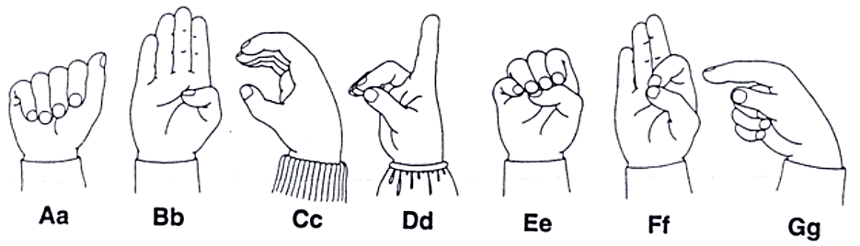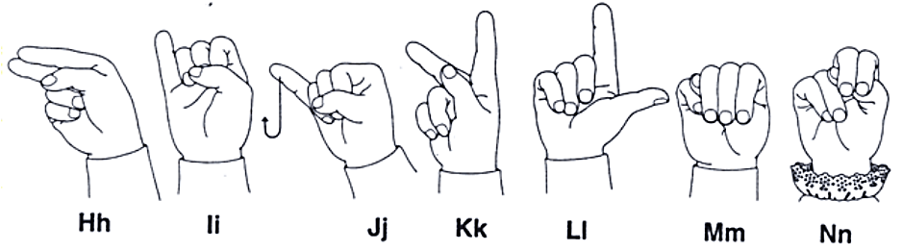  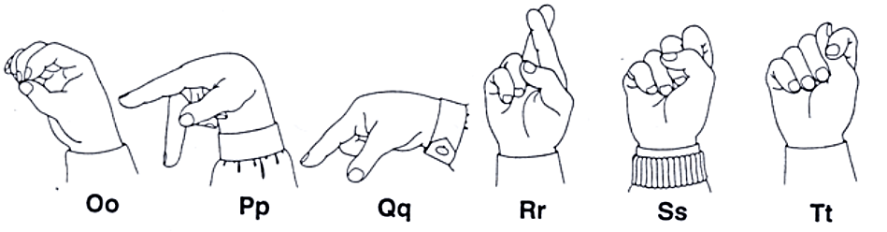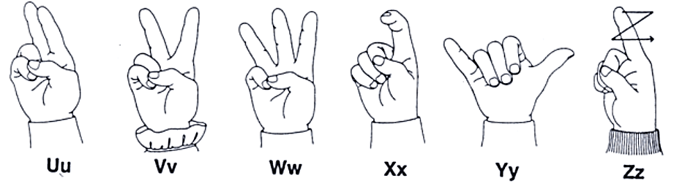  Option 2: Read my lips  - Have two teams set up and the first person on each team must watch the teacher’s mouth.  - Set a letter with no voice, just move his/her lips in tongue in the correct way. The first team to guess correctly gets a point. | - Teacher – whole class  - Teacher-whole class/ teamwork
New lesson: 25’  1. Listen and repeat. Trace. CD 2- Track 33 5’  - Play audio. Have students listen and repeat.  - Demonstrate tracing the letters with your finger.  - Have students trace the letters with their fingers.  - Have some students demonstrate the activity in front of the class.  2. Listen and repeat.CD 2- Track 34 5’  - Have students look at the pictures.  - Demonstrate the activity.  - Play audio. Have students point to the letter as they hear it.  - Play audio again. Have students listen and repeat.  - Have one student demonstrate in front of the class and ask him/her to choose one of his/ her friend to continue the activity.  3. Sing.CD 2- Track 35 5’  - Have students look at the lyrics.  - Read the lyrics as a whole class.  - Play audio and have students listen.  - Play audio again and have students listen and sing along.  4. Listen and clap. CD 2- Track 36 5’  - Demonstrate the activity.  - Have students stand up.  - Have students clap when they hear the letter sound.  Optional activities 5’  Option 1: Letter chain  - Place letter cards from a to l on the board.  - Ask one student to say the first letter.  - Ask another student to say the next letter.  - Continue with each student saying the next letter in the sequence, returning to the beginning when necessary.  - Remove one letter. The class repeats the sequence, including the missing letter.  - Remove one more letter each time, until students are saying the whole alphabet from their memory.  Option 2: Clap, jump or hop  Have students stand up and clap when they hear the letter sound k, jump when they hear the letter sound l, hop when they hear the others. | - Teacher – whole class/ individuals  - Teacher- whole class/ individuals  - Teacher- whole class  - Teacher- whole class  - Teacher- whole class/ individuals  - Teacher- whole class/ individuals
Wrap-up : 5’  Option 1: Erase the sound  - Write the alphabet from a to l on the board.  - Have one student come to the board.  - Say a sound of a letter and have him/her erase it.  - Continue with the others.  Option 2: Phonics posters  - Divide the class into groups of five.  - Hand out sheets of paper and colored pencils.  - Children choose the “k”, “l” sound.  - They must draw pictures of one or two words with their chosen sound and color them. Somewhere on the poster they should write the sound.  - Put the phonics posters around the classroom. | - Teacher – whole class/ teamwork  - Teacher – whole class/ Team work

Comment: …………………………………………………………………………………………………………………………………………………………………………………………
…………………………………………………………………………………………………………………………………………………………………………………………

