**Name:** …………………………. **Midterm test 2 (2023-2024)**

**Class: 5** …..  **Time: 40 minutes**

**I. Fint the different sound of these groups of words (1pt)**

1. A. chessB. teach C. school D. chalk

|  |  |  |  |
| --- | --- | --- | --- |
| 1. A. come | B. month | C. mother | D. open |
| 1. A. hot | B. cold | C. slow | D. hotel |
| 1. A. small | B. day | C. fall | D. tall |
| 1. A. mouth | B. house | C. country | D. about |
|  |  |  |  |

1. 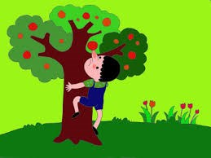**Look and write: (2pts)**

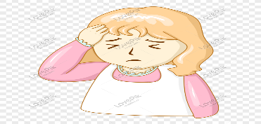 1. 2**.**

A: What’s the matter with you? A: Don’t ………..…………the tree.

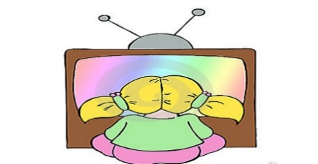 B: I have a …………………… B: OK, I won’t.

3. 4.

A: What do you do in your free time? A: What does your sister do in her free time?

B: I often ………………………… B: She often ……………………

1. **Read and match (2pts)**

|  |  |
| --- | --- |
| **A** | **B** |
| 1. When did the story about Mai An Tiem begin? | a. King Hung got angry with Mai An Tiem. He sent him and his family to an island |
| 2. Who are the characters in the story? | b. The family was lucky. |
| 3. What happened first? | c. A long time ago. |
| 4. How did the story end? | d. Mai An Tiem and his family. |
| 5. What do you think of this story? | e. In the end, King Hung let An Tiem and his family go back home. |

Key: **1 => c** ; 2 => …... ; 3 => ….. 4 => ….. ; 5 => …..

1. **Read and complete: (1 pt)**

|  |
| --- |
| ***watch free songs go twice*** |

**Hoa:** What do you do in your (0) ***free*** time, Quan?

**Quan:** I often (1) ……………. sports programmes on TV. What about you, Hoa**?**

**Hoa:** I (2) ………… to the music club with my friends.

**Quan:** How often do you go to the music club?

**Hoa: (**3) …………….. a week.

**Quan:** What do you do there?

**Hoa:** I dance and sing (4) ……………….

1. **Put the words in order to make sentences (2 pts)**
2. free / what / do / in / you / time / do / your /?

…………………………………………………………………………………

1. fishing / usually / goes / he/ in/ free/ his / time / .

…………………………………………………………………………………

1. shouldn’t / You / eat/ sweets/ lots of / .

…………………………………………………………………………………

1. ride / Don’t / your / bike/ fast / too / !

…………………………………………………………………………………

1. **Write about what you would like to be and do in the future (2 pts)**

My name is …………………………

I’m studying at …………………………………………………………………….

I’d like to be ……………………………………. in the future because I’d like to ……………………………………………………………………………………..

In my free time, I’d like to ………………………………………………………..

***Good luck!***