DAI LOC DEPARTMENT OF EDUCATION & TRAINING |  |  | THE FIRST SEMESTER TEST
HUA TAO PRIMARY SCHOOL |  |  | Subject: English- Grade: 4
Full name…………………………………… |  |  | School year: 2023-2024
Class: ……………………………………… |  |  | Time: 35 minutes
Marks | Comment(s) | Listening(3) | Reading & Writing (5) | Speaking(2)

PART A. LISTENING
Question 1. Listen and draw lines. There is one example.(1pt)
0
1
2
3
4


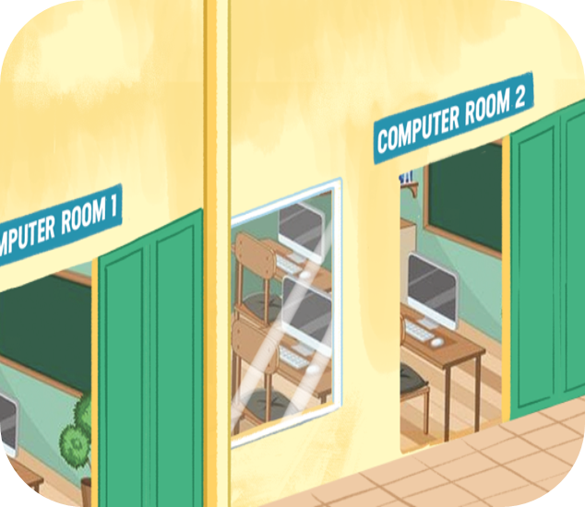

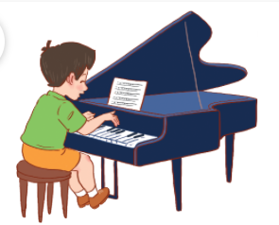
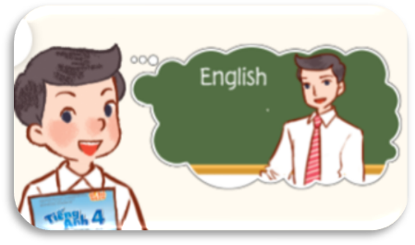

- B. C. D. E.

Question 2. Listen and tick the correct answer. There is one example.(1pt)
0.
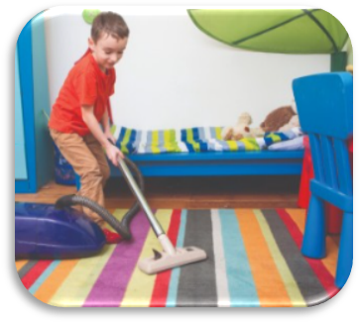



A.
B.
C.

1.

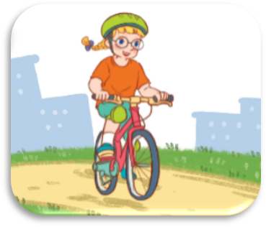


A.
B.
C.

2.
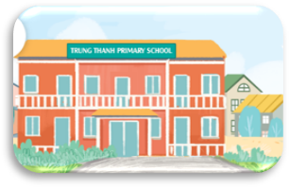
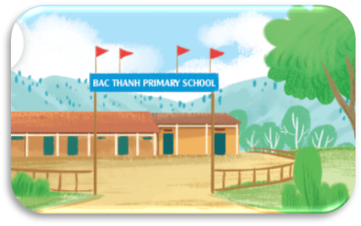
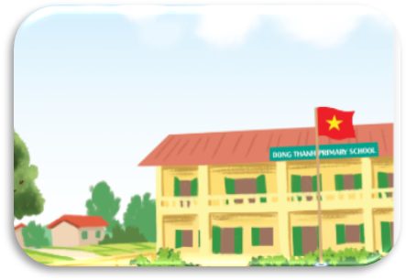

A.
B.
C.

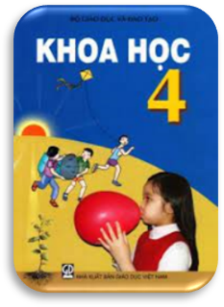
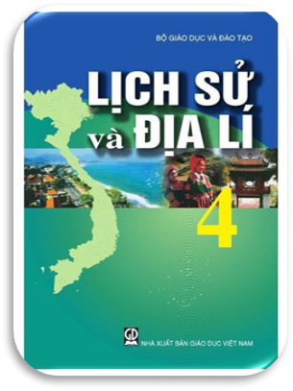

3.

A.
B.
C.

4.
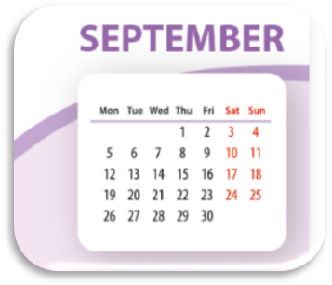



A.
B.
C.

Question 3. Listen and answer each question with one word. There is one example.(1pt)
0. Where are you from?
I’m from Australia.
1. What do you do on Saturdays?
I …………………………………………..
2. When’s your birthday?
It’s in …………………………………….
3. Where’s your school?
It’s in the ………………………. ………..
4. When do you have music?
I have it on ………………………………
DAI LOC DEPARTMENT OF EDUCATION & TRAINING |  |  | THE FIRST SEMESTER TEST
HUA TAO PRIMARY SCHOOL |  |  | Subject: English- Grade: 4
Full name…………………………………… |  |  | School year: 2023-2024
Class: ……………………………………… |  |  | Time: 35 minutes
Marks | Comment(s) | Listening(3) | Reading & Writing (5) | Speaking(2)
PART B. READING AND WRITING

Question 4. Read and tick. (1,25pt)
0. A. I’m from Thailand.
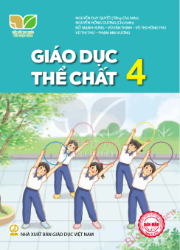
B. I’m from Japan.

1. A. My favourite subject is PE.
B. My favourite subject is IT.

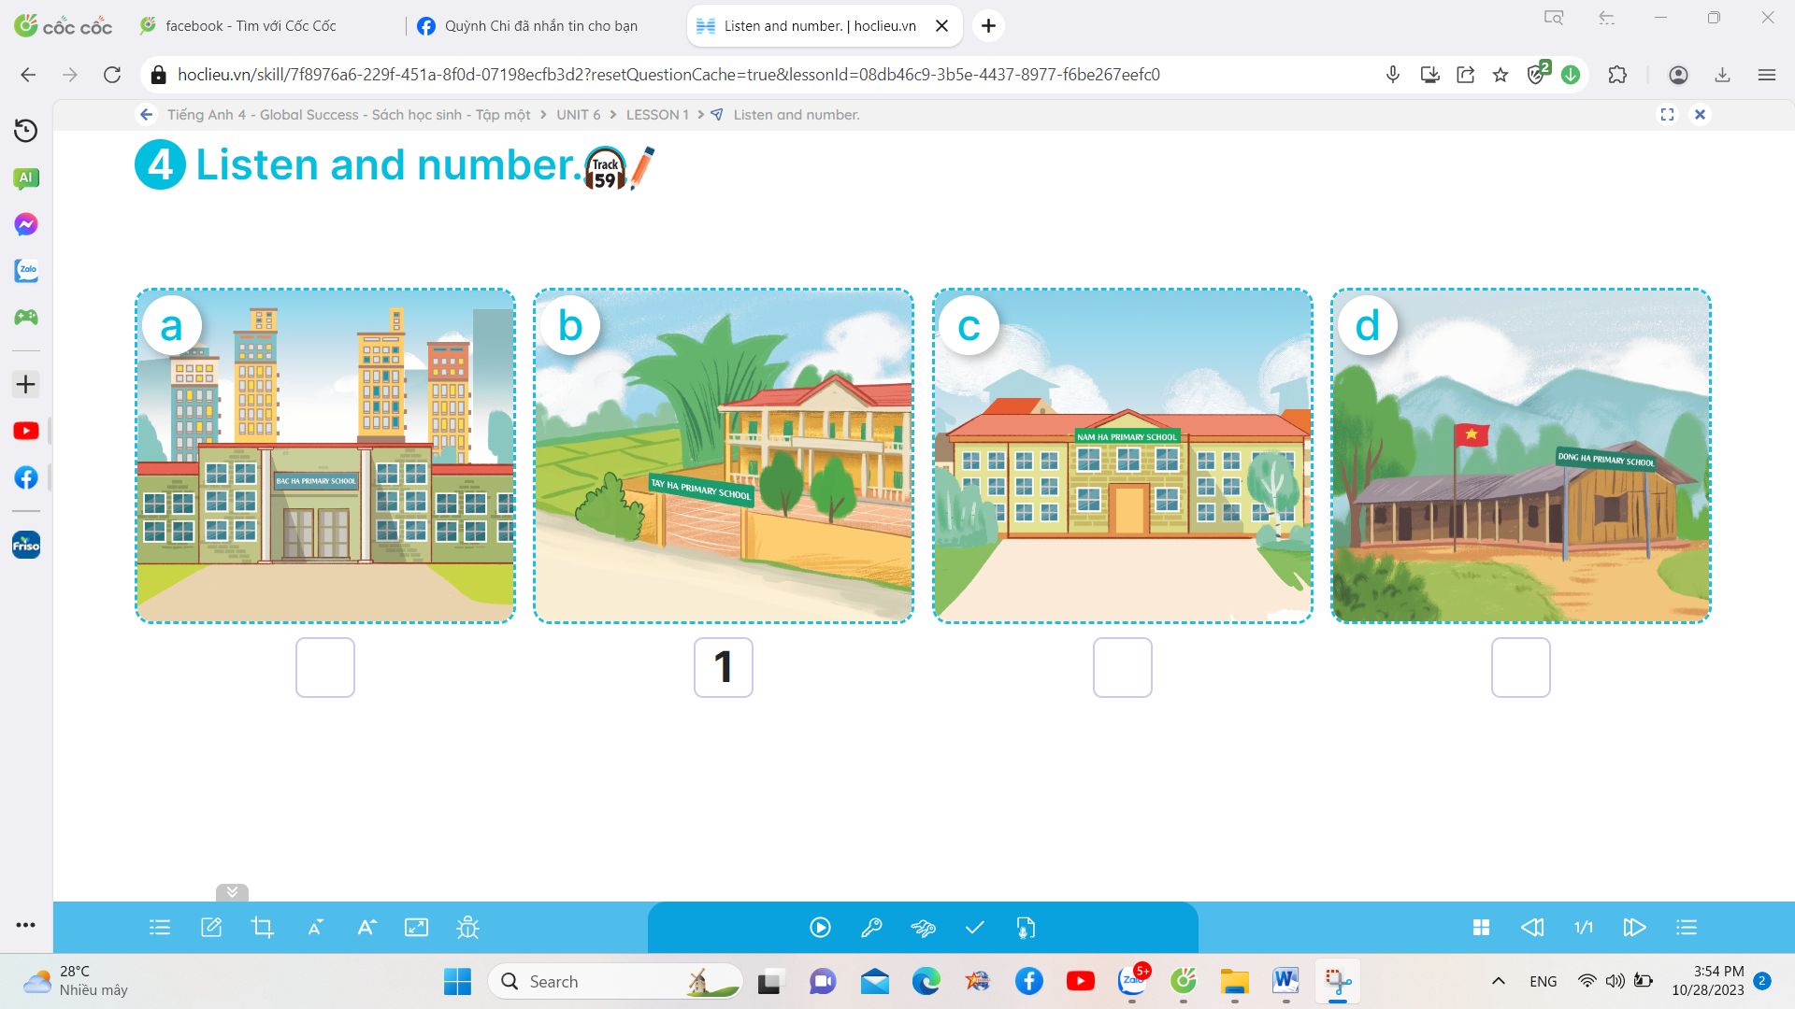
2. A. My school is in the village.
B. My school is in the city.


3. A. What day is it today? It’s Monday.
B. What day is it today? It’s Saturday.

4. A. I can draw. 5. A. I want some grapes.
B. I can cook. B. I wantsome water.

Question 5. Read and complete. There is one example. (1,25pt)
has school playground favourite studyvillage

Hi, I’m Jenny. This is my (0) school with three buildings. It’s in the (1)……………………….. There are three gardens and a (2)……………………. in my school. Here is our music room. We (3)…………………. music here on Wednesdays. My school (4)………………….. an art room. We study art there on Fridays. It’s one of my (5)……………………….subjects. It’s really fun.

Question 6. Read, choose and write the correct answers. There is one example. (1,5pt)
Hello. I’m Linh. I’m from Thanh Hoa, Viet Nam. I’m 10 years old. My birthday is in February. I’m in Class 4A at Le Manh Trinh Primary School. It’s in the village. I like playing sports but I can’t swim or play badminton. I like riding a bike on Saturdays and riding a horse or skip on Sundays. I go to school from Mondays to Fridays. My favourite subject is English. I like English because I want to be an English teacher. I do not go to school at the weekend.
Circle the answers (1pt)
0. How old is Linh?
A. 4 years old B. 10 years old
C. 14 years old D. 18 years old
1. Where is Linh’s school?
A. in February B. in Viet Nam
C. in Le Manh Trinh Primary School D. in the village
2. What does Linh like doing on Saturdays?
A. Riding a horse or skipping B. Swimming
C. Playing badminton D. Riding a bike
3. What is Linh’s favourite subject?
A. maths B. science C. English D. history
4. Can Linh swim?
A. No, she can’t. B. Yes, she can.
C. Yes, she can’t. D. No, she can.
Write the answers (0,5pt)
- When does Linh go to school?
She goes to school ……………………………………..
- Why does the speaker like English?
Because she wants ……………………………………….
Question 7. Rearrange the words to make complete sentences. ( 1pt)
0. she / a/ Can / bike/ ride?
Can she ride a bike?
1. December / Is / in / sports / your / day/?
……………………………………………………………………………
2. school / three / villages / near / my / There / are/.
……………………………………………………………………………
3. were / Where / you/ summer / last?
…………………………………………………………………………..
4. I/ history/ have/ and/ geography/ on/ Tuesdays/ Thursdays/and
……………………………………………………………………………

PART C. SPEAKING
- Interview ( 0,5pt)
- What’s your name?
- How old are you?
- Where are you from?
- What’s your hobby?
- When’s your birthday?
- Can you swim?

- Point and say (1pt)
  1. |   2. | 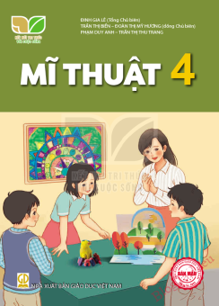  3.
4. | 5. | 6.
7. | 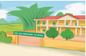  8. | 9.

III. Answer the questions. (0,5 pt)
1. What time do you have breakfast?
2. Where is your school?
3. What is your favorite subject?
4. What do you do on Sundays?
5. Why do you like English/ maths/ art/ music?
6. Where were you last summer?
7. When’s your sports day?
8. What subjects do you have today?
9. How many buildings are there at you school?
10. What do you want eat/ drink?

