# ĐỀ CƯƠNG ÔN TẬP HỌC KÌ II MÔN TIẾNG ANH 5 NĂM HỌC 2023-2024

**Task 1. Read and tick True or False. There is one example (0).**

My dad and I have the same hobby. We both like fishing very much because it is a quiet sport. There are a lot of big -trees around quiet ponds and rivers in our neighborhood. We often go fishing there. Dad and I can sit for hours to wait for the fish. We often talk about my study or our relatives.

1. My father and I like different sports. **F**
2. Fishing is a quiet sport. ……….
3. We often go fishing in the forest. ……….
4. My father and I often talk to each other while fishing. ……….
5. We can't sit long when we go fishing. ……….
6. We have friendly chats while fishing. ……….

A long time ago, the father of two brothers died. The elder brother got most of the land and the younger brother got only one starfruit tree. One day, a big bird came and ate the starfruit. Then it carried the younger brother to an island to get gold. His brother knew about this. He waited for the bird. And the bird also brought him to the island to get gold. He was greedy and got a lot of gold. The bag was very heavy and he fell off the bird, into the sea.

1. The elder brother got more land than his brother. **T**
2. The younger brother had only one starfruit tree. ……….
3. A big bird ate the starfruit and paid gold for the elder brother. ……….
4. The bird also carried the elder brother to the island to get gold. ……….
5. The younger brother got a lot of gold and carried the bird home. ……….
6. The greedy elder brother fell into the sea because of the heavy gold. ……….

# Task 2. Read and number the sentences in the correct order. The conversation begins with

|  |  |  |  |
| --- | --- | --- | --- |
|  | A | A: | Can I take a bus to get them? |
|  | B | B: | You're welcome |
| 0 | C | A: | Excuse me, is there a pharmacy near here? |
|  | D | B: | Not necessary. You can walk about five minutes. |
|  | E | A: | Thank you. |
|  | F | B: | Yes. There's one in Lemon Street. |

|  |  |  |
| --- | --- | --- |
|  | A | ***Mummy:*** What would you like to cat, dear? |
|  | B | ***Boy:*** OK. Here you are. |
|  | C | ***Mummy:*** How many sausages would you like? |
| 0 | D | ***Boy:*** I'm hungry, Mummy. |
|  | E | ***Mummy:*** I'd like two. |
|  | F | ***Boy:*** : I'd like some sausages. |

|  |  |  |
| --- | --- | --- |
|  | A | **Mike**: I watched the weather forecast on TV last night. |
| 0 | B | **Mia**: Let's go for a picnic tomorrow. |
|  | C | **Mike**: Ok, let's stay at home and watch movies then. |
|  | D | **Mia**: Really? How do you know? |
|  | E | **Mike**: Tomorrow? It will be cold and rainy! |
|  | F | **Mia**: Well, we can't go for a picnic if it's rainy. |

|  |  |  |
| --- | --- | --- |
| 0 | A | Jane: What are you looking for on the Internet? |
|  | B | Dick: Shopping is fun, right? |
|  | C | Jane: Oh, really? Great! Who are you going with? |
|  | D | Dick: I want to find some good camping sites. |
|  | E | I like going shopping. |
|  | F | Dick. My family. What do you like doing in your free time? |

|  |  |
| --- | --- |
|  | A. Jim: Oh boy! How did the story end? |
|  | B. Mai: First, a crow had a piece of meat in his beak. Then a fox came and asked it for the meat. The crow shook its head. Next, the fox asked it to  sing. It opened his beak and dropped its meat. |
|  | C. Jim: Wow, the fox is very wise. |
|  | D. Mai: In the end, the fox got the meat and ran away. |
| 0 | E. Jim: What happened in the story The Fox and the Crow? |
|  | F. Mai: That's right. I love the story very much because it gave me a good  lesson in life. |

**Task 3. Read and fill each gap with one word from the box. Write the word next to the number. There is one word that you do not need. There is one example (0).**

## fly island boat museum coach plane faster

Con Dao is a beautiful (0) ***island*** in the South of Viet Nam. From Ha Noi you can (1) to

Ho Chi Minh City. It takes about one hour and forty-five minutes. From there, there are two ways to go to Con Dao: you can take a (2)…………. to Vung Tau. and then take a (3)… to

Con Dao. It takes around twelve hours. Or you can go by (4) It's only a forty-five-

minute flight. It is (5) but more expensive.

## biscuits countryside milk rice toothache cake chocolate

This is Lucy. She lives with her parents in the (0) **countryside**. She likes sweet things very much. In the morning, she has two packets of (1) ………….and a glass of(2)… for breakfast. After

lunch, she eats a bar of (3)……………….. . In the afternoon. she cars a big (4)……………… After dinner, she eats a pocket of candy. Yesterday, she had a terrible (5)… The

dentist said that she should eat sweet things only twice a week, and brush her teeth after meals.

## lake school fishing parents swimming food skate

Summer holiday is great.We do not go to (0) ***school*** and we can do a lot of things. I like

(1)………….. .Igo to the swimming pool three times a week. My brother Nick can't swim but he can (2) very well. He often goes skating with his friends in their free time. When our

(3)………….……… are free at the weekend, we often go (4) in the neighborhood.

Mom prepares a lot of delicious (5)… We can fish and enjoy our meal outdoors.

## animals race asleep winner hare line tortoise

One day, there was a (0) race between a hare and a tortoise. First, the (1) ran very fast

and soon passed the tortoise\_ Then he stopped and fell (2) under a tree. The tortoise

walked and walked very slowly. And he passed the sleeping hare. In the end, he passed the finish

(3)…………….. . The (4)…………….. cheered loudly for the (5) The hare woke

up and began to run again, but it was too late.

## Task 4. Complete each sentence using the given words..

1. What / matter / you?

……………………………………………………………………………….

1. I / a toothache /.

……………………………………………………………………………….

1. You / should / to / doctor/ .

……………………………………………………………………………….

1. Don’t / play / knife /.

……………………………………………………………………………….

1. Why / shouldn’t / play / knife / ?

……………………………………………………………………………….

1. Because / you / get / burn/ .

……………………………………………………………………………..

1. Why / Tom / ride / fast / ?

……………………………………………………………………………..

1. Because / he / fall / bike / .

……………………………………………………………………………..

1. What / you / in / free time /?

……………………………………………………………………………..

1. I / go / cinema /.

……………………………………………………………………………..

1. Nam / surf / internet /.

……………………………………………………………………………..

1. Quan / do / karate/.

…………………………………………………………………………….

1. What / your brother / in / free time /?

…………………………………………………………………………….

1. He / often / go / fishing/.

…………………………………………………………………………….

1. What / you / like / be / in the future/?

…………………………………………………………………………….

1. I / like / be / doctor/.

…………………………………………………………………………….

1. What / Quan / like / be / in the future/?

…………………………………………………………………………………….

1. He / like / be / astronaut/.

…………………………………………………………………………………….

1. Why / you / be / architect /?

…………………………………………………………………………………….

1. Because / I / like / design buildings/.

…………………………………………………………………………………….

1. Why / Phong / be / doctor /?

…………………………………………………………………………………….

1. Because / he / like / take care/ patients.

…………………………………………………………………………………….

1. How / I / get / the post office/?

…………………………………………………………………………………….

1. You/ take / bus/.

…………………………………………………………………………………….

1. What / you / like / eat /?

…………………………………………………………………………………….

1. I / like / eat / banana/.

…………………………………………………………………………………….

1. What / you / like / drink /?

…………………………………………………………………………………….

1. I / like / drink / orange juice/.

…………………………………………………………………………………….

1. How / bananas / you / eat / everyday/?

…………………………………………………………………………………….

1. I / three bananas

…………………………………………………………………………………….

1. How / milk / you / drink / everyday/?

…………………………………………………………………………………….

1. I / drink / two / glasses/.

…………………………………………………………………………………….

1. How / sausages / you / eat / everyday/?

…………………………………………………………………………………….

1. I / one sausage

…………………………………………………………………………………….

1. What / weather / be / like / tomorrow/?

…………………………………………………………………………………….

1. It / hot / sunny / tomorrow/.

…………………………………………………………………………………….

1. What / summer / like / country?

…………………………………………………………………………………….

1. It’s / hot / . / There / flowers.

…………………………………………………………………………………….

1. Which place / you / like / visit/?

…………………………………………………………………………………….

1. I / like / visit / Hoi An Ancient Town/.

…………………………………………………………………………………….

# Task 5. Read the questions. Write about yourself.

1. What's your name?
2. Where is your school?
3. How far is it from your school to your house?
4. Are there any buildings next to your school?
5. How do you often get to your school?
6. I low long does it take you to go to school?

0. Hello. My name is…………………………………………. My school is……………………

………………………………………………. ……………..It is …………………………………

……………………… There are …………………………………………………………. …….. I ……………………………………………………………. It takes……………………………..

………………………………………………

# . Write about your favorite food and drinks. There is one example (0).

1. What's your name?
2. What's your favourite food and drink?
3. How much do you eat it every day/week?
4. What's your favourite drink?
5. How much do you drink it every day/week?
6. Do you like sweets? Why or why not?

My name is …………………… ………………………………..I like eating……………………..

………….……………………………I…………………………………………………………… I like drinking………………………………………………1 ……………………………..

… a day.

# Write about your favourite story.

1. What's your name?
2. What's your favourite story?
3. Who is the main character in the story?
4. What happened in the story?
5. Flow did the story end?
6. What do you think of the main character? Why?

0. My name's ……………………….My favourite story is …………………………

…………………………………….. . The main character is …………………………

………………… First, …………………………………………………………………

………………….Then, …………………………………………………………………

…………………In the end, …………………………………………………………….

I think he/she ……………………………………………………………………………

# Write about your favourite season.

1. What's your name?
2. Where do you live?
3. How many season are there in your place?
4. What are they?
5. What is your favourite season?
6. What the weather like in your favourite season?

0. My name's ……………………….I live ………………………………………………...

…………………………………….. . There are …………………………………………..

………………… They are …………………………………………………………………

………………….My favourite season is …………………………It’s usually…………… There ……………………………………………………………………………….

# MỘT SỐ ĐỀ THI MẪU

**LISTENING (20 minutes) (5pts).**

## Part 1: Question 1-6: Listen and number. There is one example. (1,5pts).

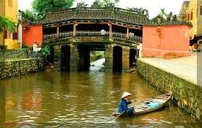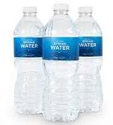

*0*

***Part 2:: Listen to each question and circle the best answers. There is one example.* (1pt).**

***Example:*** *0/ ...............*

A *I have a toothache. B. He has a stomach ache. C. She has a headache.*

7/ ....A. She’d like to be a nurse B. I’d like to be a teacher. C. He’d like to be a pilot.

8/ ....A. I went there by train. B. I went there last month C*.* I went there with my sister. 9/ .....A. It’s sunny and windy. B. It’s hot in summer. C. It’ll be cold and windy.

10/ ...A. She lives in London. B. She lives with her uncle. C. She lives in a house.

## Part 3: Question 11-15: Listen and tick (🗸) the correct picture. There is one example (1,25pts)

*0.*

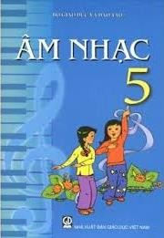

A*.*

11.

B*.* C*.*

A*.* B*.* C*.* 12.

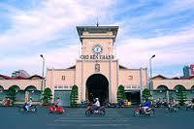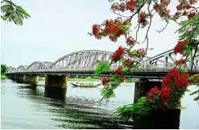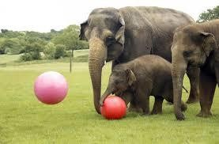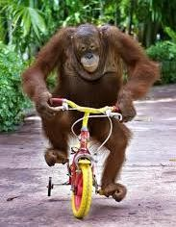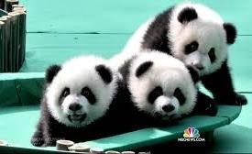

A*.* B*.* C*. * 13.

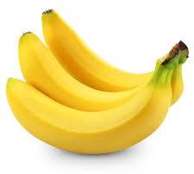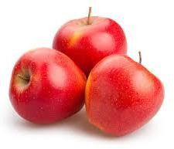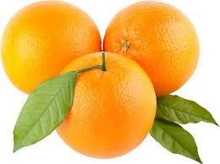

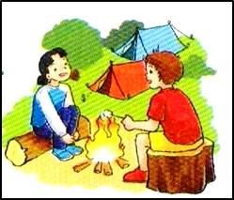A*.* B*.* C*.* 14.

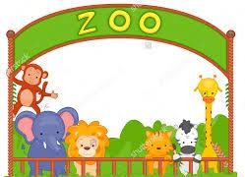

A*.* B*.* C*.* 15.

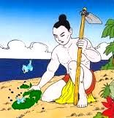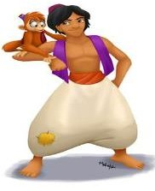

A*.* B*.* C*.*

***Part 4: Question 16-20: Listen and tick (***🗸***). There is one example* (1,25pts)**

|  |  |  |  |
| --- | --- | --- | --- |
|  | | **T** | **F** |
| *0* | *Her name is Mary.* | 🗸 |  |
| 16 | She lives in Australia. |  |  |
| 17 | She gets up at 6 o’clock every morning. |  |  |
| 18 | She goes to school at 7:15. |  |  |
| 19 | In the afternoon, Mary plays chess with her friends. |  |  |
| 20 | She often watches TV. |  |  |

# READING (20 minutes). (5pts)

## Part 1: Question 1-5: Read and fill in the gaps . There is one example (1,25pts)

Hi! My name is *(0)* ***Mai***. Among the school subjects, I like (1) ...................best because I can talk with my classmates Tom, Linda and Tony easily. I’m good at listening and speaking English. I hope that I will become a teacher of English some day. Nam, Quan and Phong are my classmates, too. Nam also likes English very much. He likes watching (2)................... on TV every evening and reading English stories. Quan doesn’t like English. He has problems of pronunciation. Art is his favourite subject. He can draw well. He would like to be an (3)

................. in the future. Phong’s favourite subject is (4)....................... He wants to know about (5).............. and animals. He hopes he will be a scientist some day.

|  |  |  |  |  |  |
| --- | --- | --- | --- | --- | --- |
|  |  |  |  |  |  |
|  | Description: C:\Users\Administrator\Desktop\IMG20161003094533.jpg |  |
| Science | plants | English | artist | Mai | English cartoons |

***Part 2: Question 6 -10: Read and tick. There is one example.* (1,25pts)**

|  |  |  |  |  |  |
| --- | --- | --- | --- | --- | --- |
| My name is Hoa. I live in Binh Minh. It is a small and quiet village in Thai Binh Province. It has got a lot of trees and not many people. There are not many shops. There is only one primary school in the village. Hoa likes living in her home village because it is peaceful. My close friend is Thang. He lives in Nam Giang. It is a big town in Nam Dinh Province. It is larger than Binh Minh village and it is noisier. It has got few trees, but it has got many cars and shops.  The houses and schools are bigger. Thang prefers living in his hometown because it is exciting. | | | | | |
|  | | |  |  |  |
|  | | | **True** | **False** |  |
|  | *0* | *Hoa lives in Binh Minh village.* | 🗸 |  |
| 6 | There are not many trees in Binh Minh village. |  |  |
| 7 | There is only one primary school in Hoa’s village. |  |  |
| 8 | There are many cars and shops in Nam Giang town. |  |  |
| 9 | Binh Minh village is smaller than Nam Giang town. |  |  |
| 10 | Thang doesn’t like living in his hometown because it is boring. |  |  |

***Part 3: Question 11 -15: Read and number sentences to make a complete dialogue. There is one example* (1,25pts)**

|  |  |
| --- | --- |
| **Nam:** Yes, I did. |  |
| **Quan:** How about tomorrow. What will the weather be like? |  |
| **Nam:** It’ll be warm and foggy in Ho Chi Minh city, It’ll be windy in Ha Noi. |  |

|  |  |
| --- | --- |
| ***Quan:*** *Did you watch the weather forecast last night, Nam?* | ***0*** |
| **Nam:** Umm, It’s hot and sunny in Ho Chi Minh city, it’s cooler in Ha Noi. |  |
| **Quan:** What is the weather like today? |  |

***Part 4: Question 16 - 20: Read and choose the best answer. There is one example* (1,25pts)**

Hi, I’m Nam. A few months ago, I visited Singapore with my father, one of the most famous cities in Asia. Singapore is a small island. The city of Singapore is extremely beautiful. There are many places of interest such as the Tiger Parm Garden, the Botanical Garden and Raffles Museum.

During my stay in Singapore, I went out every day with my father to see the beautiful and interesting places in the city. First, we went to the Tiger Parm Garden where I can saw some statues of people and animals. Second, we visited the Raffles Museum where I saw hundreds of curious things preserved for scholars and others. Third, I visited the Nature Park and went round the town to visit some of the cinema. I really love my trip in Singapore.

*0. Nam visited .......... a few months ago.. A. Singapore B. Korea C. Thailand*

1. He went there with his ............. A. father B. mother C. friends
2. Singapore is a .......... A. big island B. small island C. small land
3. First, Nam and his father went to ............
   1. the Raffles Museum. B. the Nature Park. C. the Tiger Parm Garden.
4. Nam saw at the Tiger Parm Garden.
   1. some statues of people B. some animals C. some statues of people and animals
5. Nam didn’t visit ......... in Singapore. A. the cinemas B. the parks C. the zoo

# WRITING (20 minutes) (5 pts)

## Part 1: Question 1- 5: Read and complete. There is one example. (1,25pt)

My name is Tony. I often read science *(0)* ***books*** and do sports in the gym. I want to be



strong and good at science because I would like to be a(1) 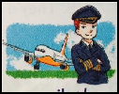 I want to fly planes. My friends Mai and Linda like different things. Mai often reads books. She would like to

be a (2)  because she would like to write stories for children. Linda often



1. pictures in her free time. She would like to be an



1. because she would like to design (5) .

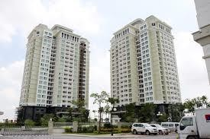

***Part 2: Question 6-10:Complete each sentence using the given words. There is one example***

# (1,25pts)

*0. What / matter/ with/ you? → What is the matter with you?*

1. What / you / like / eat?

*→ ............................................................................................*

1. What / your brother / do / his/ free time?

*→ ............................................................................................*

1. Peter/ would / like/ pilot/ in/ future.

*→ ............................................................................................*

1. What/ you / think /of/ Snow White?

*→ ..........................................................................................*

1. The weather/ sunny/ windy/tomorrow.

*→ ............................................................................................*

## Part 3: Write a letter to tell your friend about your village/hometown/city. Using guiding questions (2,5pts) (about 35-45 words)

*Where do you live? How many seasons are there? What are they? What’s your favourite season? Why?*

Dear. ,

...........................................................................................................................................................

...........................................................................................................................................................

..........................................................................................................................................................

...........................................................................................................................................................

……………………………………………………………………………………………………….

[**ĐỀ THI ĐÁNH GIÁ NĂNG LỰC TIẾNG ANH BẬC A1**](https://nguyenthithuangvty.violet.vn/present/same/entry_id/12016417/same/show) **DÀNH CHO HỌC SINH LỚP 5**

**Thời gian: 60 phút**

**READING ( 20 minutes )**

**PART 1: Look and write the correct words. There is one example.**

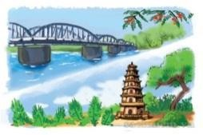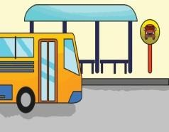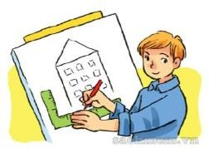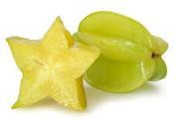

Bridge bus stop architect gold starfruit roof

1. This fruit has a star shape. starfruit
2. A yellow precious metal used to make coins or jewelry. ......................
3. We wait for the bus at this place. ..................... ..
4. We build it to cross the river ......................
5. He designs houses and buildings. .......................
6. The top of the building or the house . ...................... **PART 2: Read and fill each gap with one word from the box. Write the word next to the number. There is one word that you do not need. There is one example (0).**

|  |  |  |  |  |  |  |
| --- | --- | --- | --- | --- | --- | --- |
| C:\Users\Admin\Desktop\image5.jpg | C:\Users\Admin\Desktop\image3.jpg | C:\Users\Admin\Desktop\mam-com-cuoi-tuan.jpg | C:\Users\Admin\Desktop\images862615_dem_halong.jpg | C:\Users\Admin\Desktop\image4.jpg | C:\Users\Admin\Desktop\tải xuống.jpg | C:\Users\Admin\Desktop\image7.jpg |
| ***Rain*** | ***buildings*** | ***food*** | ***City*** | ***Caves*** | ***eggs*** | ***traffic*** |

This is Tho from Ha Long( 0) City. Life here is exciting. There are lots of tall (1) . The

(2) is busy on the long and wide roads. The people here are very friendly. The famous bay has beautiful beaches and (3) . The (4) is fresh and healthy. The best time for visitors to Ha Long Bay is from March to June. Don’t go in July or August because there’s lots of (5)

**PART 3: Read and tick https://s.sachmem.vn/public/sm-quizz/icons/checkbox-tick.png** **True or False. There is one example .**

I’m Lisa. I like reading comic books in my free time. My favourite comic book is “ ***The Queen of Egypt***” I’ve read three times and enjoyed it so much. My sister gave me this book on my birthday. The language is simple and easy to understand. The main characters are a girl and a boy. Girl’s name is Carol. She is kind and clever. The name of the boy is Menisu. He is brave and generous. I love Carol very much because she is beautiful and clever.

|  |  |  |
| --- | --- | --- |
|  | **True** | **False** |
| 0. Lisa’s favourite book is “ The Queen of Egypt”. | https://s.sachmem.vn/public/sm-quizz/icons/checkbox-tick.png | https://s.sachmem.vn/public/sm-quizz/icons/checkbox-default.png |
| 1.She has read it twice and enjoyed it. | https://s.sachmem.vn/public/sm-quizz/icons/checkbox-default.png | https://s.sachmem.vn/public/sm-quizz/icons/checkbox-default.png |
| 2. She likes reading science books in her free time. | https://s.sachmem.vn/public/sm-quizz/icons/checkbox-default.png | https://s.sachmem.vn/public/sm-quizz/icons/checkbox-default.png |
| 3. She loves the girl because is beautiful and clever. | https://s.sachmem.vn/public/sm-quizz/icons/checkbox-default.png | https://s.sachmem.vn/public/sm-quizz/icons/checkbox-default.png |
| 4. Her brother gave her a comic book on her birthday. | https://s.sachmem.vn/public/sm-quizz/icons/checkbox-default.png | https://s.sachmem.vn/public/sm-quizz/icons/checkbox-default.png |
| 5. Menisu is brave and handsome.. | https://s.sachmem.vn/public/sm-quizz/icons/checkbox-default.png | https://s.sachmem.vn/public/sm-quizz/icons/checkbox-default.png |

# PART 4: Read and choose the best answer A, B,C or D. There is one example

Hi! I’m Nam. I want to be a doctor when I grow up because it is a meaningful job. If I become a doctor I will cure sick people in hospital. I think doctors need to be kind and caring. They have to take care of patients so they must be healthy. Doctors should be friendly to sick people. I will study hard and learn to be patient so that I can be a good doctor. I hope my dream will come true one day.

* 1. What does Nam want to be when he grows up?
     1. He wants to be a doctor. B.Yes, He does.

C.He wants to be a nurse. D.He wants to be a teacher.

1. Why does he want to be a doctor ?
   1. Because it is a meaningful job. C. Because it is a good job.
   2. Because it is a dream job. D. Because he wants to work in the hospital.
2. What will he do if he becomes a doctor?
   1. He will take care of people. B. He will cure sick people.

C. He will cure strong people. D. He will study hard and learn to be patients.

1. How does a doctor need to be?
   1. A doctor needs to be kind and gentle C. A doctor needs to be strong and good.
   2. A doctor needs to be good and caring. D. A dotor needs to be easy going.
2. Which of these is not true about the text ?
   1. Doctors need to be kind and caring. C. Doctors must be healthy.
   2. Doctors should be friendly to sick people. D. Doctors must be clever and brave.
3. What does he hope in the future?

A.He hopes his dream will come true one day. B.He hopes he will cure many patients C.He hopes he will get a job with high salary in the future. D. He hopes he will be patient.

# WRITING ( 20 minutes )

**Part 1: Quetion 1 - 5: . There is one example**

To get enough vitamins, minerals and fiber, you should first choose red, orange, and dark-green vegetables like (0) tomatoes , sweet potatoes, and (1) 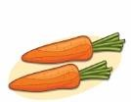

and other vegetables for your meals. You can eat fruits after meals. For main meals, you should eat “ brown” rice or (2)  . You can choose lean protein foods such as beef,

chicken, seafood, peas and (3) 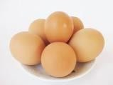 . Remember to eat fewer foods with fat such

as cakes, cookies, sweets, ice-cream and fatty meats like (4) 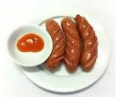 and bacon. Fresh milk, (5)  and plain water are good drinks for your health.

**Part 2: Reorder the words to make sentences. There is one example.**

1. like / a / Mary / would / scientist. / to / be /

**Mary would like to be a scientist.**

1. a / hard / to /doctor. / studies / Mai / become /
2. Mai / Why / winter? / doesn’t / like /
3. week. / Tran Quoc Pagoda / with / classmates / We / visited / last /our /
4. living / in / city. / parents / the / My / countryside / than / enjoy / in / the /
5. often / the / police / Jimmy Kudo/ secretly. / helps /

# Part 3: Read the questions. Write about your favourite season. There is one example (0).

1. What is your name?
2. Where do you live?
3. How many seasons are there in your place? What are they?
4. What season do you like best?
5. Why do you like it? What about the weather?
6. What do you usually do in this season? What kind of sport do you often play in this season? My name is ……………
7. I live in……………………………..
8. There are…………………….They are……………………………………..
9. Of all the seasons I like… best.
10. I like this season because………………………………The weather is…………………
11. During this season, I usually…………………………............I often play……………… **Full name:**…………………………………………. **Time: 60 minutes Class:**………………………………………………. **School year: 2016- 2017 PART II. READING (20 minutes)(5 pts)**

# Question 1: Look and read. Choose the correct word or phrase to fill the gaps as

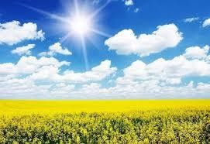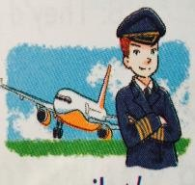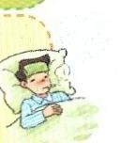**example.(1,25 pts)**

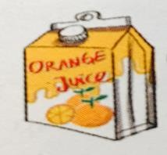

## A.summer B.Ha Long Bay C. orange juice D.pilot E.comic books F.fever

1. IT’s a famous place where people often go on holiday. B. Ha Long Bay
2. He would like to fly a plane. ….…………………….
3. It is a healthy drink. ………………………...
4. He has a high temperature. ………………………..
5. Most of children like reading them. ………………………...
6. It’s very hot and sunny in this season. ………………………… **Question 2: Read and write True (T) or False (F) in the gaps. There is an example. (1,25 pts)**

My name is Quang. I live in Can Tho. It is in the south of Viet Nam. There are only two seasons here. They are the dry season and the rainy season. The dry season lasts from November to April. It is usually cool and dry in this time of the year. This is my favorite season because I can go for a picnic with my friends. The rainy season lasts from May to October. It is usually hot and wet. There is a lot of wind too.

1. Quang lives in Can Tho. ......**T**......
2. Can Tho is in the North of Viet Nam. .................
3. There are two seasons in Can Tho. ................
4. The weather is cool and dry in the dry season. .................
5. The rainy season lasts four months. ................
6. The weather is usually hot and rainy in the rainy season. ................

# Question 3: Read and reorder the sentences to make a complete dialogue. It begins with 0. (1,25 pts)

|  |  |  |
| --- | --- | --- |
| **A** | Mai: I’m going to Hau Giang Province. |  |
| **B** | Tony: How are you going to get there? |  |
| **C** | Mai: Yes, quite far. |  |
| **D** | Tony: Where are you going next weekend Mai? | **0** |
| **E** | I think I’ll go by coach. |  |
| **F** | Is it far from Ho Chi Minh City? |  |

**Question 4: Look and read. Fill in each gap with a suitable word from the boxes.(1,25pts)**

|  |  |  |  |  |  |
| --- | --- | --- | --- | --- | --- |
|  |  |  | Description: E:\tranh\hinh nhan vat\nhan.jpg |  |  |
| buildings | traffic | shops | Nam | crowed | village |

Hello. My name is *(0) Nam.* I I live in a (1)… in Vinh Phuc Province. It’s

about sixty kilometers from Ha Noi. It’s small and quiet. There are not many people, shops and

(2) I enjoy living here because life is peaceful and the people are friendly. At the

weekend, my parents often take me to Ha Noi. It’s much noisier and busier. It has lots of large lakes, beautiful parks and tall (3) ……………. The streets are so (4) and things

are more expensive. I like Ha Noi because the (5) are really nice and life is exciting.

# III: WRITING (20 minutes). (5 pts)

**Question 1: Look at the pictures, read and write one word for each gap. There is an example. (1,25 pts)**

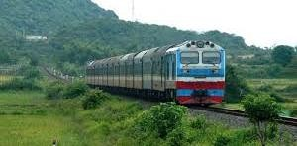

1. *I went to Ha Noi by* ***train*** *last summer holiday.*
2. The weather will be cold and in Ha Noi tomorrow.



1. She would like a glass of ...........................



1. You need vitamins from for a healthy body.
2. Children shouldn’t play out on the ..................................

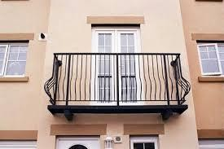

1. She would like to be a .................................. because she’d like to look after patients.

# Question 2: Reorder the words to make complete sentences. There is an example. (1,25 pts)

Example: 0. I /the / visit / tomorrow/ Islands / will .

I will visit the Islands tomorrow.

1. in/ would / to / What/ like/ future / you/ be / the /? /

………………………………………………………………………………

1. bike / too / don’t / your / fast / ride / ! /

………………………………………………………………………………

1. free / do/ brother / your / what / in / does /time / his /? /

………………………………………………………………………………

1. carton / juice / I / like / please / of / would / a / apple /, / . /

………………………………………………………………………………

1. Da Nang / cool / weather / in/ will / the / tomorrow / be / cloudy / and/ . /

………………………………………………………………………………

# Question3: Write about your hometown.(2,5 pts)

**Guiding questions:** 1.What is your name? 2.Where do you live?

3.What is your hometown like? 4.How are the people and the air?

5.Why do you like living here?

My name is (0) Hoa.I live in (1) It’s a (2) in

Quang Nam. There are many trees in my hometown so the air is (3) The

people here are very (4) . I like living here because It’s (5)

# SPEAKING. (11minutes). (5 pts)

**Part 1: Question 1-5: Get to know each other.**

1. *What’s your name?*
2. *How old are you?*
3. *What do you do your free time?*
4. *What is your favourite subject/ food/drink?*
5. *What would you like to be in the future?*
6. *Which place would you like to visit? Why?*

# Part 2: Question 6-10: Talk about a familiar food or drink. ( Choose a or b)

## ( Use pictures of fruit)



1. *Take a picture of your favourite fruit please.*
2. *What are they?*
3. *What colour is it?*
4. *How much/many. do you eat every day?*
5. *Should we eat fruits every day? Why? Why not?*

## b. ( Use pictures of drink)

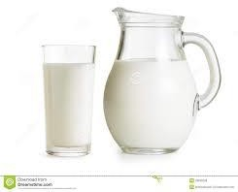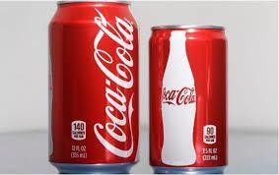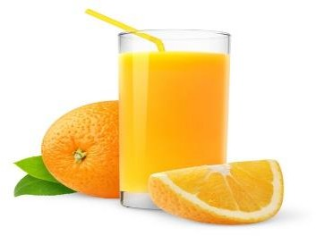

1. *Take a picture of your favourite drink please.*
2. *What is it?*
3. *What colour is it?*
4. *How much/many. do you drink every day?*
5. *Should we drink fruit juice every day? Why? Why not?*

# Part 3: Question 11-15: Describe the picture:

*( Use cards of some common stories)*

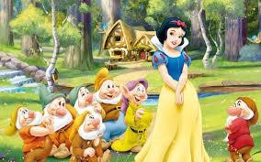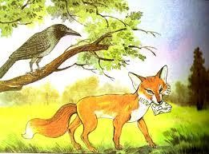

1. *What is the name of the story?*
2. *What can you see in the picture?*
3. *What is the main character of the story?*
4. *What do you think of the main character?*
5. *Do you like him/her? Why? Why not?*

***=====The end=====***

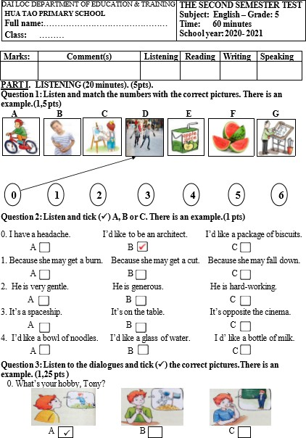

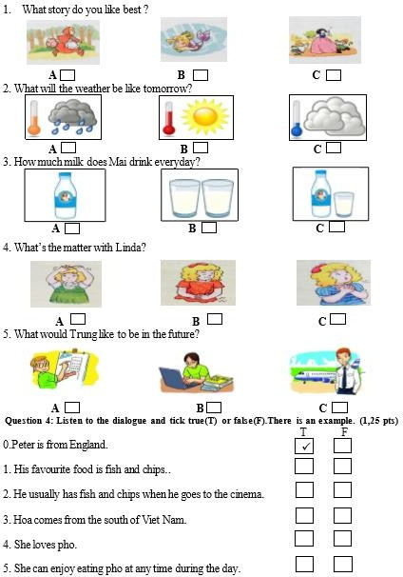

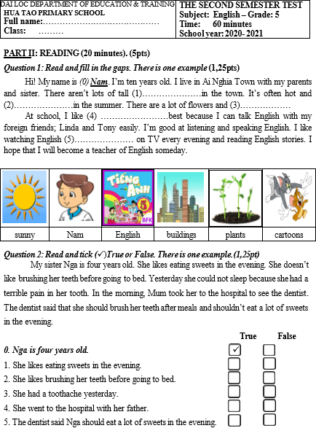

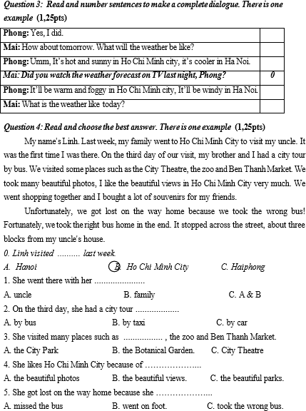

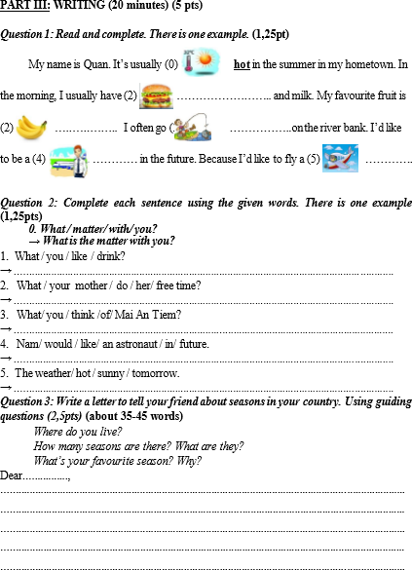

**SPEAKING**

**Question1: Talk about your hometown.**

**Guiding questions:**

0.What’s your name?

1.Where do you live?

2.What is your hometown /place like?

3.How many seasons are there in your hometown /place?

4.What are they?

5.What do you think of the life in your hometown /place?

My name is (0) ………………

I live in (1)…………………………………………………………………………

It’s (2)………………………………………………………………………………

There are (3)………………………………………………………………………

They are (4) ............………………………………………………………………

I think (5) ............…………………………………………………………………

………………………………………………………………………………………

**Question2: Talk about what you would like to be and do in the future.**

**Guiding questions:**

0.What’s your name?

1.What class are you in?

2.What school do you study?

3.What would you like to be in the future?

4.Why would you like to be a / an …………..?

5.What would you like to do in your free time?

My name is (0) ………………

I’m in class (1) ………………….

I study at (2)…………………………………………………………………….

I’d like to be (3)……………………………………………….... in the future.

I’d like to (4)………………………………………………………………………

In my free time, I’d like (5) ............……………………………………………...

............……………………………………………………………………………..

**Question3: Talk about the seasons and the weather**

0.What’s your name?

1.Where do you live?

2.How many seasons are there in your country?

3.What are they?

4.What’s your favourite season? Why?

5. What’s your favourite season like in your country?

My name is (0) ………………

I live in (1)……………………………………………………………………….

There are (2)………………………………………………………………………

They are (3) ............………………………………………………………………

My favourite season is (4) ............………………………………………………

It’s usually (5)……………………………………………………………………

There is / are (6)………………………………………………………………...

**Question 4. Reorder the word to make sentences**

*Example: My / is / small / pretty. / but / hometown/ =>My hometown is small but pretty.*

1. will/ What/ the/ tonight? / like / be/ weather

* ..........................................................................................................................

2. I /autumn/like/ is/ cool./because/ weather/ the

* ..........................................................................................................................

1. more / Your / my / chair. / chair / is / beautiful / than /

* ..........................................................................................................................

1. go / summer. / will / his / country / back / to / Tom / this /

* ..........................................................................................................................

5. something/ you /Would/ like/ to/ drink?

* ..........................................................................................................................

6.in / a / Tony / Nam Linh Plaza. / lives / flat / of /

* ..........................................................................................................................

7.living / They / on / Nguyen Du Street. / are / a building / in /

* ............................................................................................................................

8.. What/ is/ the/ today? weather/ like =>.........................................................................................

9.. are / in / country./ There / four / seasons/my

=>.........................................................................................................................................................

5. eats/ She/ four/ bars/ day. / chocolate/ a/ of =>................................................................................