Name: …………………………. SEMESTER 2 TEST GRADE 1
Class: ………………………….
LISTENING
PART 1: Listen and number the pictures. There is one example. 4 questions - 1.0 point
 |  | 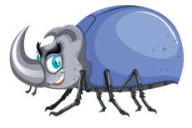 |  | 
 |  | 0

PART 2: Listen and put a tick () in the box. There is one example. 4 questions - 1.0 point
Ex. | 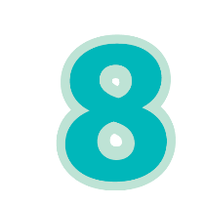 | 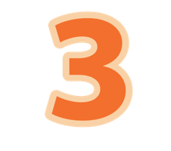 | 
 | A | B | C
 |  |  | 
 | A | B | C
6. | 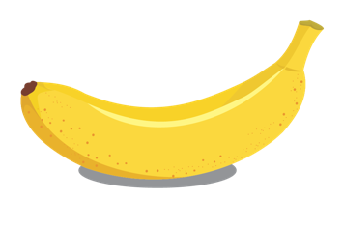 | 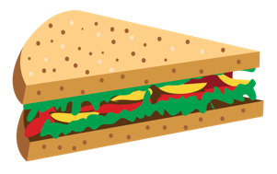 | 
 | A | B | C
7. | 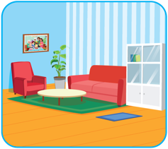 |  | 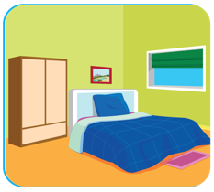
 | A | B | C
8. |  |  | 
 | A | B | C
PART 3: Listen and corlor the pictures. There is one example. 4 questions - 1.0 point
Ex.
9.
10.
11.
12.
READING
PART 1: Look, read and tick () Yes or No. There is one example.
3 questions - 1.5 points
 |  |  | YES | NO
Ex. |  | I can sing.
 |  | I have a cookie.
 |  | How old are you?  I’m three.
 |  | This is my kitchen.

PART 2 Look, read and draw lines. There is one example. 3 questions - 1.5 points
 |  | 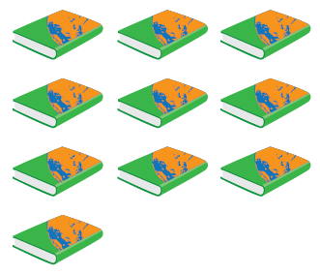 | 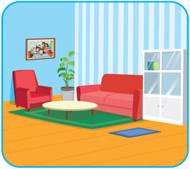
I can kick. | I can sing. | This is my living room. | I have ten books.

PART 3 Look, read and circle the correct answer. There is one example.
4 questions - 2.0 points
Ex. |  | This is my juice. | This is my book.
7. |  | I can run. | I can swim.
8. | 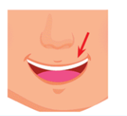 | This is my mouth. | This is my mouse.
9. |  | I want a sandwich. | I love my mom.
10. | 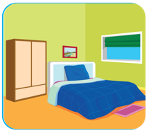 | This is my kitchen. | This is my bedroom.
WRITING
PART 1 : Order the letters. There is one example. 3 questions – 0.75 points
Ex. |  | n e s e v | s e v e n
1. |  | l l a b | __ __ __ __
2. | 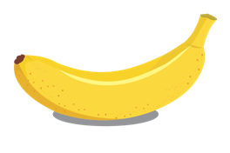 | a a a b n n | __ __ __ __ __ __
3. |  | n i g s | __ __ __ __
PART 2 : Look and write. There is one example. 3 questions - 0.75 points
Ex. |  | I can see a m o u s e .
4. |  | I can __ __ __ __ .
5. | 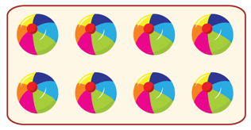 | I have __ __ __ __ __ __ __ __ __ __.
6. |  | This is my __ __ __ __ __ __ __ __ __ __ .
PART 3 2 questions - 0.5 points
Reorder the words to make a correct sentence. There is one example.
I
swim.
Ex.
can
I can swim.
is
my
This
bedroom.
7.
bears.
I
teddy
have
four
8.

